COMP1682 Final Report

**Project Name**

**Student Name**

**Supervisor: **name\*\***

**Final Year Report**

**COMP1682 Final Year Project**

**Program Title: BSc Hons Computing**

**Word count: 10.000 (Minimum)**

**Abstract**

This report will cover the topic of direct bus ticket booking. Booking bus tickets directly is quite simple and convenient process. To book a bus ticket, you not only need to go to the address of the nearest bus station or ticket office to buy, but we will book tickets directly from the staff or through the booking system directly on the website of the bus operator. Usually, the booking process takes only a few minutes to complete. Once you have your ticket, you just need to arrive at the bus station on time to get on the bus and enjoy your ride. And this cable article will clearly show about booking bus tickets through the form is direct.

**Acknowledgements**

I would like to thank everyone who helped and contributed to the completion of this work. I would like to especially express my gratitude to my mentor, Mr. Thai Minh Tuan, whose advice and guidance laid the foundation for this project and helped me overcome difficulties during the project implementation. his judgment. I would also like to thank everyone who supported and facilitated me to complete this report within the allotted time. Your help has helped me stay focused and get the job done the best I can.

Table of contents

1. Introduction 6

1.1 Background 6

1.2 Aim 6

2. Objectives 7

3. Approach 8

3.1 Justification of the suitability of a Methodology or a Framework followed. 8

4. Literature Review 9

4.1 Approach to literature searching 9

4.2 Technology A 9

4.3 Technology B 9

4.4 Technology C 9

4.5 Market analysis 9

5. Legal, Social, Ethical and Professional Issues and Considerations 10

6. Requirements 11

6.1 Analysis of requirements 11

6.2 Existing Solutions 11

6.2.1 Product A 11

6.2.2 Product B 11

6.2.3 Product C 11

6.2.4 Conclusion 11

7. Business Requirements 12

7.1 Overall Picture 12

7.2 Functional Requirements with MoSCoW prioritisation 12

7.3 Non-functional Requirements 12

8. Analysis and Design 13

8.1 Architecture 13

8.2 High Level Design 13

8.2.1 Assumptions 13

8.2.2 Overall 13

8.2.3 Endpoints 13

8.2.4 3rd party Services 13

8.3 Technology choices 13

8.3.1 Front End 13

8.3.2 Back End 13

8.3.3 Mobile App 13

8.4 Use case Diagram 13

8.4.1 Primary and Secondary Use-case scenario 13

8.5 Entity Relationship Diagrams 13

8.5.1 Physical design (Capacity) 13

8.6 Wireframes for prototypes 13

8.7 Class Diagram 13

8.8 Activity Diagram / Sequence Diagram 13

9. Implementation 14

9.1 Database 14

9.2 Front End 14

9.3 Back End 14

9.4 Deployment 14

9.5 Images 14

10. Testing 15

11. Evaluation 16

11.1 Summarised Key findings from the project 16

11.2 Recommendations for future development 16

11.3 Project Evaluation 16

11.4 Personal Evaluation 16

11.5 Conclusion 16

11.5.1 What went well? 16

11.5.2 What did not go well? 16

11.5.3 What have I learned from this project? 16

11.5.4 Future development 16

12. References 17

13. Appendix A – Project Proposal 18

14. Appendix B 19

15. Appendix C 20

# Introduction

## Background

At present, the social economy is developing year by year, in order to keep up with and integrate with the economies of fast developing countries in the world. The regions together have experienced an increasing economic restructuring leading to an increasing shift in the laboratory or structure. Since then, the more people move to work and residence, the higher the travel needs of people. Besides, the economy develops tourism industry, so the demand for travel and sightseeing of people also increases.

In the economy of exchanging goods and passengers between regions is increasing, traveling has become easier, but with the current situation of buying bus tickets, it is still a very difficult problem. Wanting to buy a ticket as you want is not an easy thing to do when you have to queue to buy tickets at agents and box offices, especially during the holidays. It just takes time and effort, but it is not certain that the passenger has a satisfactory seat, sometimes it is not possible to buy a ticket. Or you can call to make a reservation, but when you get in the car, you will be crammed, the quality of service attitude is extremely bad.

In the current situation, transport businesses are still using the traditional way of managing and selling tickets in the era when the country is modernizing the country. The management and sale of tickets in the traditional way leads to many risks: congestion when buying tickets, overload of customers waiting, time loss, especially during holidays and Tet.

Along with the development trend of information technology, the 4.0 technology revolution is going into every corner of life, the passenger transport field is no exception. When passengers have a need or have to move. by long-distance coach and feel the craftsmanship in the ticketing process and the agony of passengers when they are allowed to queue in the heat to wait to buy a ticket. The 4.0 technology revolution is changing the way people communicate with each other, the way businesses do business and the way we create products in a big industry. Those are important prerequisites for the bus ticketing industry to apply information technology to online ticket sales with practical benefits for passengers. High-quality bus tickets can now be booked online with many advantages such as: the ability to choose seats, e-tickets to board the bus, this booking method has been applied by many bus operators. development of an airline ticketing system for bus route companies was born at the right time and in the actual situation of the economy. People just need an internet connection, access to the bus ticketing website to buy bus tickets even when busy and free, with just a few clicks, they can buy tickets anywhere.

Since then, I personally decided to choose the topic Developing ticket booking system for bus route companies. This system will help bus companies solve the problem of passengers buying tickets on the spot, avoiding many risks, saving time and bringing high efficiency.

## Aim

The development of an online ticket booking system through a website not only helps transportation companies save expenses on printing and distributing tickets, but also enables customers to book tickets more easily and conveniently. This system will synchronize data on prices, departure/arrival times, types of buses and number of available seats, helping to manage and allocate resources more efficiently. Furthermore, customers can also search for information on schedules, prices, and book tickets through a single screen quickly and easily. In addition, the online ticket booking system through the website also helps transportation companies gather customer information, which in turn serves customers better and improves service quality. In summary, the goal of this project is to develop an online ticket booking system through a website to help bus companies optimize resource management and enhance customer experience.

# Objectives

## 2.1 Analyze requirement

**Activity:** In this activity, I need to learn, read, and analyze requirements. Then they will go to collect information and select the right and necessary information for themselves. Next will be planning and timing your project.

2.1.1 Read and Analyze Requirements

2.1.2 Collect information

2.1.3 Selecting information

2.1.4 Make a plan

2.1.4 Schedule the project implementation

## 2.2 Design project

**Activity:** In this activity I will need to research and refer to related or similar projects to figure out how to do my project. Next I will shake hands and code for my project and interface design work parallel to my coding work.

2.2.1 Consult multiple code source

2.2.2 Writing code

2.2.3 Design interface

## 2.3 Testing

**Activity:** In this activity, after writing the project's code, the author needs to test the program to see if the program is as required. In the process of testing, there is an error or a part that is not as required, the author needs to correct it and re-test it again to make sure the code is correct.

2.3.1 Run code of project

2.3.2 Debug error and edit

2.3.3 Last test

## 2.4 Writing report

**Activity:** At this final stage, after I have completed my project, I will perform the activity that is to demonstrate my project. Next will be implementing your project, monitoring the project's operation. And the end will be to maintain the project to edit the necessary things.

2.4.1 Show project

2.4.2 Project implementation

2.4.3 Monitor the progress of the project

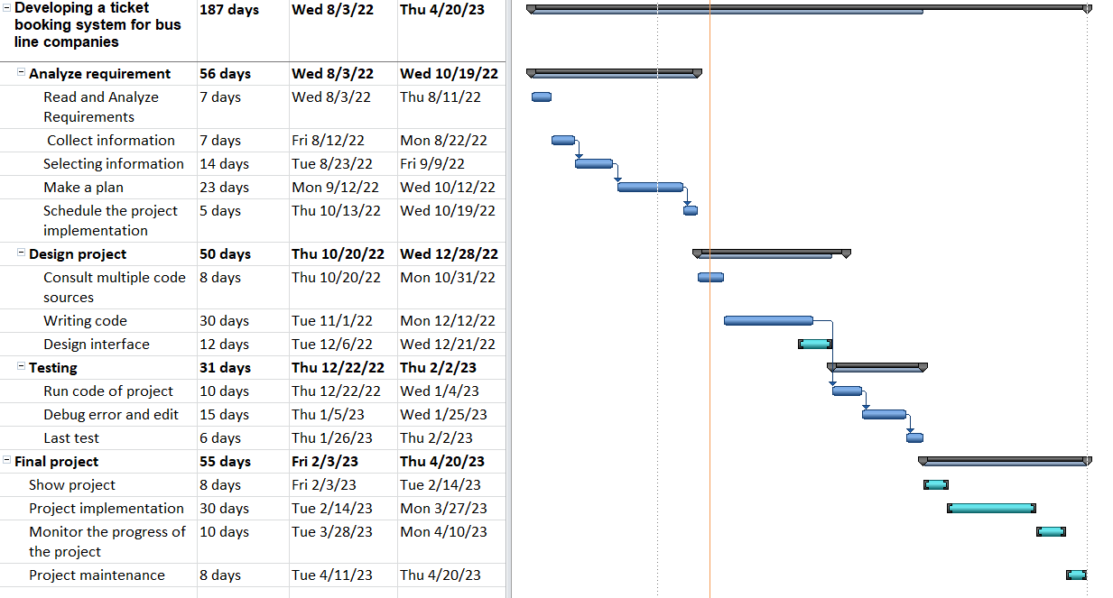2.4.4 Project Maintenance

Figure II.1 Grant chart

# Approach

# The Waterfall model is a fundamental software development life cycle model that used to be widely used in the past and played an important role in the history of software development. This model divides the software development process into various stages, with each stage focusing on a specific task. One stage only begins after the previous one is completed, and the output of each stage serves as the input for the next stage.

# The Waterfall model is simple and easy to understand, and its sequential nature and non-overlapping stages allow for better management and control of the software development process. However, this model also has its limitations, as it is not suitable for large and complex software projects and cannot adapt to changing customer requirements.

# Although the Waterfall model is no longer widely used today, it is still considered one of the most notable software development life cycle models in history. All other software development life cycle models developed later are based on the basic idea of this model. This demonstrates the importance and influence of the Waterfall model in software development

## Justification of the suitability of a Methodology or a Framework followed.

## Selecting a suitable software development model for a project is an important factor in managing and completing a project successfully. The Waterfall model is a good choice for certain projects.

## If the requirements of the project can be determined concretely in the initial stage and there are not many changes in requirements during the development process, the Waterfall model works well. Different stages in the Waterfall model are designed to handle a specific part of the software development process, maintaining sequence and ensuring the quality of the software product.

## The Waterfall model is often used for small and simple projects. Since the stages need to be completed before moving on to the next phase, risk factors can be detected early and effectively resolved while the project is still in development. Therefore, the Waterfall model has numerous applications in software projects that are simple, or software projects that have well-defined functionality and requirements, with little client changes during the development process.

## In conclusion, the Waterfall model is a good choice for simple projects, optimizing sequence in the development process, and is suitable for well-defined requirements and little client changes in the development process.

# Literature Review

## Approach to literature searching

An office informatics tool that aids in the process of looking for relevant document information on a broad scale, from a single search page but contains the information of Several professions also have particular sources is better understood than Google Scholar. The articles on this website are original, thesis-scale, book summaries, or expert-written pieces. a library at a faculty, university, or other building.

Office productivity software including Google Slides, Microsoft Word, Microsoft Excel, and Microsoft Powerpoint... The ability to identify and filter more precisely about academic research is especially helpful when using the Google Scholar tool. Academic research in the field of research contains exactly the same quantity of knowledge produced by experts. Purer access is made possible for those in need with the use of this tool's unique, cost-free search function.

The introduction of Google Scholar has provided us with several benefits, including: The location is ideal for searching and finding articles on the web, and the sources of information are varied at any given time. The website has an online library system. Look for publications with fair citations and succinct summaries to utilize later. You can obtain informational articles with endless papers from numerous sources regardless of the business you work in; you just need to make your choice. Google Scholar, which offers more usefulness and convention than Google, will have a selection of articles. Moreover, the articles must be in file format, and occasionally Google searches take a while to complete.

## Automated Bus Ticket Reservation System for Ethiopian Bus Transport System.

This study focuses on the creation of an online system for bus ticket reservations, which will allow customers to do so and boost business productivity. Tickets have traditionally been purchased over the counter in bus terminals under the current method. Issues including squandering time and money on bus tickets, creating sale reports for tickets, and ticket fraud are frequent. For the aforementioned issues, there are solutions available through the online bus ticket reservation system. The System enables the business to more effectively manage its ticket-related processes. According to the passenger's sources and destinations, the system also enables users to check the availability of bus tickets, purchase bus tickets, and pay for bus tickets online using prepaid cards. This makes it simpler for customers to purchase their bus tickets online rather than in line. This system uses object-oriented software development, and the MD-5 (Notice of Digest) algorithm is employed for security reasons. (Adam, 2019)

## Mobile – Based bus ticketing system

In Iraq and other nations, bus travel is a significant and expanding industry. As a result, each passenger who has reserved a seat for a trip gets their maintenance record processed by the bus ticketing system. The ticketing system also keeps track of each bus trip's schedule, cost, and other data. Yet, many bus operations are still carried out by hand. Manual or conventional systems operate slowly and frequently make mistakes. As a result, they encountered several issues and frequent client disputes, and each branch operated independently. To address the aforementioned and keep track of the items, client seats, and prices per seat, invoice generation, and with the introduction of mobile devices, the number of consumers is rapidly growing. The chosen mobile-based application gives bus tour companies the chance to increase their commercial performance with users. Using an agile software development process and the Unified Modelling Language (UML), the mobile bus ticketing system (MBTS) prototype was created. In order to verify that MBTS is successfully implemented in real-world settings, prototypes are assessed for usability. (Ta'a, 2015)

## Customer satisfaction towards online

E-commerce in retail travel has been made easier thanks to websites, online portals, and apps that connect IT and the Internet. The most well-liked and affordable means of transportation is the bus. In the pre-coronavirus period, this article examines consumer satisfaction for a web portal based on the interstate bus ticketing process. By using a random sample technique and questionnaires to gather primary data from 400 respondents who frequently take interstate buses, a descriptive study was carried out in the city of Bengaluru. According to data study, age and skill level are key factors in determining how well people use online portals or Internet control technologies based on the Application. The younger generation of commuters favors purchasing bus tickets from online websites and assists the elderly in doing the same. Consumers are pleased with the organization, style, and functionality of the website as well as the reservation and refund procedures. (Lalitha.K, 2020)

## Efficiency Analysis of Online Ticket Reservation System in Rajasthan State Road Transport Corporations (RSRTC) Using ITS & ICT Enabled Services

A society like ours's socioeconomic development is inextricably linked to the development of road passenger transportation. In our nation, both governmental and commercial entities offer passenger transport services. The current study examines the nature of passenger transportation in India and, in particular, in Rajasthan, with a focus on Rajasthan State Road Transport Corporation (RSRTC), and examines the online booking system and associated problems. There are still some concerns that need to be handled carefully despite increases in bus capacity and availability. The fundamental issue is the RSRTC's poor financial performance or condition, among all other issues. Since a few years ago, the RSRTC has been a losing institution. Despite the fact that there are numerous solutions to this issue, it is crucial to draw in more customers and to give them more convenience. Now, it is claimed that among those methods, online ticket purchasing is also significant in the contemporary digital era. Although the appropriate RSRTC authorities have made numerous efforts in relation to online booking, it is noted that there are still a few issues that annoy and dissatisfy travellers and couples. when there is an altercation between passengers and RSRTC employees. So, an effort is made in this article to evaluate and comprehend the RSRTC's current online booking system, try to identify the issue, and recommend potential fixes by utilizing ICT-enabled solutions without adding undue financial strain to the RSRTC. having monetary issues. (Parihar & Sharma, 2019)

## Bus ticket reservation system

One of the most significant developments on the Internet is e-commerce. Without limitations due to distance or time, it enables instantaneous exchange of goods and services. People can stand in line and purchase practically anything they choose at any hour of the day or night. The Puduraya Bus Ticketing Agency (PBTA) system is an e-commerce-based application. Anyone can access the databases of the bus companies online thanks to a client/server design. The main goal of PBTA is to give residents in Puduraya a more practical means to purchase bus tickets. Users and administrators are the two key modules in this application. Anyone can obtain information and make bus reservations using the user module. The administrator module gives administrators more tools for managing and maintaining online databases. It is firmly believed that the advent of the PBTA System will improve both the service provided by bus operators and the comfort and ease of people's lives. (KUANG, 2021)

## Analysis and Practical Application of PHP Frameworks in Development of Web Information Systems

This article compares and provides an overview of the popularity of the several PHP programming frameworks (CakePHP2, CodeIgniter, Symfony2, Yii, and PhalconPHP). Symfony2 and PhalconPHP were chosen for detailed research based on the data gathered during the project. This article provides an overview of the architecture and key characteristics of a few frameworks (routing, template engine, etc.). A performance test was created for framework comparison in order to assess the performance and efficiency of frameworks when performing the same task. A cashier list area for the "Ticket Reserving System" was selected for performance testing. Tests were carried out using the Apache Web server's built-in utility ab.exe (Apache Benchmark). A framework for building a practical Web project can be selected by Web developers using recommendations based on the comparative results. It is intended to use Web services based on open standards and protocols to improve the created Web system's capabilities (SOAP, XML-RPC, REST, etc.). (Prokofyevaa, 2017)

## HTML5 and the evolution of HTML; tracing the origins of digital platforms

Prior to the release of HTML5 (Hypertext Markup Language), HTML (Hypertext Markup Language) underwent a significant development during the past ten years (Hypertext Markup Language 5). Due to the rising fragmentation and complexity of protocols, platforms, devices, and systems, certain elements created around HTML during this time period created substantial issues for the development of the standard. Initial differences between the W3C (World Wide Consortium) and other digital platforms regarding the best course of action were resolved with the creation of the WHATWG (Web Hypertext Application Technologies Working Group) and the widespread adoption of HTML5. Yet, the creation of HTML5 has paved the way for significant modifications to the creation of web standards as well as the function of the Web as a techno-social platform. This study offers a retrospective throughout a historical analysis of HTML's development, throwing some light on the technical, economic, and social elements that contributed to the development of a "Living Standard" in order to clarify these difficulties. The article is based on empirical evidence obtained from 21 interviews conducted with various HTML5 specialists and a documentation analysis surrounding the hypertext standard in order to accomplish this goal. This paper focuses on how many variables that contributed to the current state of rising centralization helped the platform economy paradigm arise. Finally, it is suggested that the role of groups like W3C and others should be expanded in order to prevent future episodes of socio-technical disputes from being fueled by the oligopolistic practices of digital platforms. (Tabarés, 2021)

## [Practical Microservices Architectural Patterns](https://link.springer.com/book/10.1007/978-1-4842-4501-9)

## Oracle Corporation created, released, and offers support for MySQL, a well-known open source SQL database management system. A structured collection of data is managed by MySQL. You can add to, access, and manipulate the data stored in the database with the aid of a MySQL database. Data is kept in distinct tables in MySQL. Physical files that are designed for speed contain the database structures. The logical model provides a flexible programming environment with objects like databases, tables, views, rows, and columns. The "Structured Query Language" (SQL) portion of "MySQL" refers to the most used standardized language for accessing databases. Open source MySQL software is licensed under the GPL (GNU General Public License). (Christudas, 2019)

## [Installing, configuring, and developing with Xampp](http://dalibor.dvorski.net/downloads/docs/installingconfiguringdevelopingwithxampp.pdf)

## The most popular web development tools are all contained in a single package in the compact and lightweight Apache distribution known as XAMPP. Its features, compact size, and portability make it the perfect tool for students creating and testing PHP and MySQL applications. There are two distinct packages of XAMPP that may be downloaded for free: full and lite. Although the entire package download offers a variety of development tools, this article will concentrate on utilizing XAMPP Lite because it has the required technologies and meets the specifications of the Ontario Skills Challenge. The light version is a compact package that includes Apache HTTP Server, PHP, MySQL, phpMyAdmin, Openssl, and SQLite, as the name suggests.. (Dvorski, 2007)

## [Beginning JavaScript](https://books.google.com/books?hl=en&lr=&id=-mp4J3nVS6MC&oi=fnd&pg=PR6&dq=javascript&ots=izIjD5OC0c&sig=SUPMol9aBGOPGZMWJHy1fKNjTXw)

## What is a computer language, exactly? JavaScript is a type of computer language. A computer language is, to put it simply, a set of directives that tell a computer what to do. Such something may take many different forms, such as requesting the user for information, displaying text, or moving an image. Code, or instructions, are typically processed from the top line to the bottom. Processed simply denotes that the computer reads the code we wrote, determines the course of action we desire, and then executes that course of action. Running or executing code is the actual process of processing it. I'll let you in on a little secret, though: your computer doesn't actually comprehend JavaScript. It is an interpreted language because it needs something to translate the JavaScript code into something it can understand. Only machine code, which is essentially a string of binary numbers, is understood by computers (that is, a string of zeros and ones). The JavaScript is processed by the browser and then sent to a specialized application called an interpreter, which translates it into machine code that your computer can comprehend. It's comparable to using a translator, for instance, to translate from English to Spanish. The crucial thing to remember is that when the code is executed, JavaScript is converted. (Wilton, 2004)

# Legal, Social, Ethical and Professional Issues and Considerations

The development of ticketing systems for bus companies not only benefits the economy but also raises very important legal and ethical issues. As more and more people depend on online shopping and transactions, it is important that these systems are built on a foundation of legal compliance and ethical responsibility. Ensuring users' personal information is protected and stored securely is a top priority for any company that operates online. In addition, companies need to comply with regulations and limit fraudulent acts in the ticketing process.

Furthermore, bus companies are responsible for ensuring the safety and security of their passengers. This includes keeping vehicles in good condition, ensuring drivers comply with traffic regulations and providing passengers with accurate and up-to-date information about their journeys. By implementing a ticketing system, bus companies can also monitor the number of passengers on each bus trip, minimizing the risk of overcrowding and ensuring the safety of their passengers.

In addition to legal and ethical issues, developing a ticketing system for bus companies poses technological and financial challenges. To implement this system, the bus company needs to invest heavily in technical infrastructure and have a team of professional technology experts to build and manage the system. Moreover, the cost of system development will also be a challenge for bus companies, however, if implemented reasonably and effectively, the ticketing system will help the company save costs, increase productivity. productivity and revenue growth.

For customers, the online ticket booking system will bring many conveniences and benefits. Online ticket booking helps customers save time traveling to traditional ticket stores, avoiding crowded situations and waiting in line to buy tickets. In addition, customers can also look up information about bus routes, fares and schedules easily online through the system.

In summary, while it can be beneficial to develop a ticketing system for bus companies, it is important to consider the legal and ethical consequences of such a system. By implementing best practices, bus companies can provide reliable and safe service, meet customer needs, and uphold their responsibility to the community. And developing a ticketing system for bus companies will bring many benefits to both companies and customers. However, to implement this system, the company needs to comply with legal and ethical regulations, invest heavily in technology and develop a sound business strategy. Customers will also enjoy many benefits and values when using the online booking system.

# Requirements

## Analysis of requirements

To complete the project and meet the customer's needs, you need to fully understand the required tasks and ensure that all project members understand them. Starting from the requirements analysis is also important, helping you understand the problem of the current system and what the customer wants. These requirements will give you the information you need to design a new system. In addition, you also need to understand all requirements related to the project, including functional, non-functional and business requirements, to ensure that everyone on the project understands and Do not leave out any important requirements. However, there is no need to prioritize the order of requirements in the initial stage, but focus on figuring out all the high-level requirements first.

Besides understanding the requirements, it is also important to define and ensure the quality of the project. To do this, you need to define criteria by which to evaluate the quality of the product or service provided, thereby ensuring the project is completed as expected and meets the customer's requirements.

In addition, the establishment of a project plan and roadmap is also very important to ensure that the project progress is carried out according to the plan, thereby helping to control the risks that make the project difficult. This plan needs to be created meticulously and specifically, and at the same time must ensure its feasibility, thereby helping all project members to complete their tasks in the most effective way.

Finally, don't forget to always monitor the project progress and make additional adjustments as needed. This helps you stay up-to-date with the latest project information and make the right decisions, while ensuring that the project is completed on schedule and meets the customer's requirements.

## Existing Solutions

### ViserBus

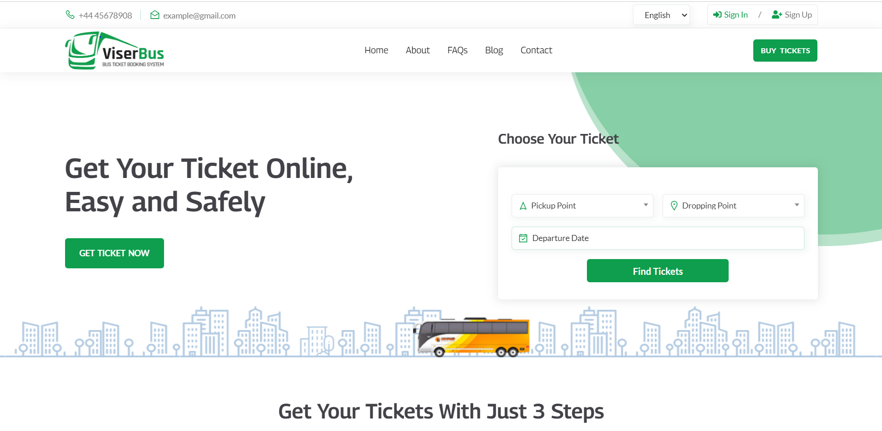

Figure VI.1ViserBus

PHP laravel is a component of ViserBus, a professional bus booking solution. It was created for those who desire to launch a website for their bus company. A total of 3 million city buses were in use worldwide as of the end of 2017; 385,000 of these are electric buses. Hence, 13% of the global fleet has the illness. Users can sign up and access their dashboards here with ease. Then, he can look for tickets to his desired location. There are over 20 different automatic payment options. The ticket will be issued automatically after the payment has been made. (ViserLab, 2023)

**Pros**

* Support cross-browser compatibility and contemporary browsers.
* A robust and effective admin interface.
* A simple, up-to-date user interface.
* Forms for submitting ads of various sizes.
* Setup of 250+ currencies and 20+ payment gateways.
* Easy functionality with all dynamic features.
* Simple Documentation. GDPR Guidelines.
* Frequent updates, premium support, and quick response.

### True Bus

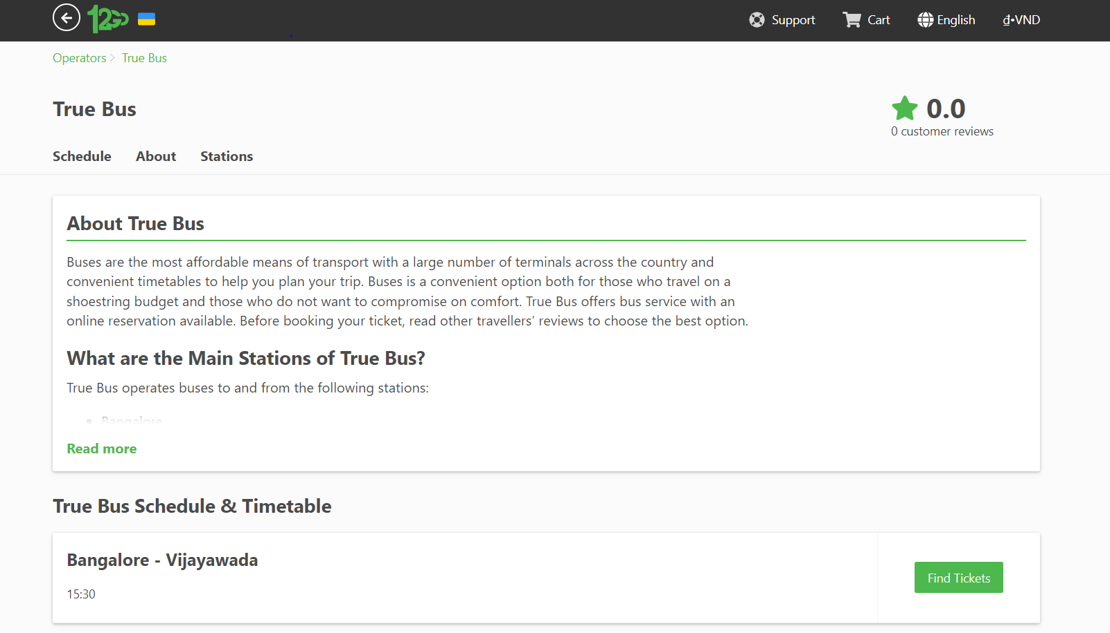

Figure VI.2 True Bus

True Bus's online reservation system for bus tickets is available for purchase on CodeCanyon.

Streaming screenshots

Built on the robust open source programming languages PHP and MySQL with the Codeigniter architecture, True Bus is an online bus ticket booking and reservation system that enables you to manage your bus inventory, prices, routes, and schedules as well as your whole back office. It is a robust piece of software made with the primary goal of creating a dynamic and automated system for all bus reservation and booking activities. With a variety of choices, The Real Bus will market your fleet management to both current and potential customers. (123go, 2023)

**Pros**

* Excellent efficiency and adaptability
* Simple Registration Process
* the PayPal payment system
* Mechanism to Cancel Tickets
* Management of time
* Managing Seat
* Booker Information
* Add suppliers
* Notifications via email
* Management Promocode
* Adaptable - Whole Source Code

## Conclusion

### After going through a number of websites with similar themes, it gave me a lot of ideas to design a website of my own. In my website will be done using Visual Stdio Code tool, Xampp. Along with that will be programming languages such as: HTML, PHP, Javascript, .. In my web application will design features such as: users search for necessary schedules and book tickets, administration and management. Manage schedules, customers, vehicles, locations with features like add, edit, delete and search.

# Business Requirements

## Functional Requirements with Moscow prioritisation

**Table 1:** Functional requirement

|  |  |  |  |
| --- | --- | --- | --- |
| **No** | **Functional requirements** | **Moscow** | **Justification** |
| 1 | Login functionally | Must have | This is a “Must have” because login is an important function in the system of any application or website. This function helps users access their personal accounts and perform necessary operations that each account has certain permissions to use. |
| 2 | Search information ticket bus line | Could have | This is a “Could have” because search is a function on a website or application. This function helps users to search for bus ticket information and locate information quickly and conveniently. |
| 3 | Booking ticket bus line | Must have | This is a “Must have” because this is the main function of the system, this function helps users to book bus tickets directly on a website. |
| 4 | Add information user booking | Should have | This is a “Should have” because add function helps users to customize and add full customer information when booking bus tickets. |
| 5 | Edit information user booking | Should have | This is a “Should have” because edit function helps users to change information user booking |
| 6 | Delete information user booking | Should have | This is a “Should have” because delete function help user delete information user booking quickly and conveniently. |
| 7 | Searching information user booking | Could have | This is a “Could have” because search is a function helps users to search information booking of user |
| 8 | Add information schedule of bus line | Should have | This is a “Should have” because add function helps users to customize and add full schedule bus for user choose ticket. |
| 9 | Edit information schedule of bus line | Should have | This is a “Should have” because edit function helps users to change information schedule of bus line |
| 10 | Delete information schedule of bus line | Should have | This is a “Should have” because delete function help user delete information schedule of bus line quickly and conveniently. |
| 11 | Search information schedule | Could have | This is a “Could have” because search is a function helps users to search for schedule ticket bus information. |
| 12 | Add information location of bus line | Should have | This is a “Should have” because add function helps users to customize and add full location information for specific address |
| 13 | Edit information location of bus line | Should have | This is a “Should have” because edit function helps users to change information location for specific address. |
| 14 | Delete information location of bus line | Should have | This is a “Should have” because delete function help user delete information location of bus line quickly and conveniently. |
| 15 | Search information location | Could have | This is a “Could have” because search is a function helps users to search for location for specific address |
| 16 | Add information bus | Should have | This is a “Should have” because add function helps users to customize and add full information bus for user choose bus and schedule suitable. |
| 17 | Edit information bus | Should have | This is a “Should have” because edit function helps users to change information of bus line |
| 18 | Delete name bus | Should have | This is a “Should have” because delete function help user delete information name bus quickly and conveniently. |
| 19 | Searching information bus | Could have | This is a “Could have” because search is a function helps users to search for bus |
| 20 | Update profile | Could have | This is a “Should have” because edit function helps users to change information your profile. |
| 21 | Logout functionally | Should have | This is a “Should have” because this functionality allows users to exit their login account and end their session on the website or application easily and securely. |

## Non-functional Requirements

**Table** 2: Non-functional requirement

|  |  |  |
| --- | --- | --- |
| **No** | **Non-functional requirements** | **Justification** |
| 1 | User friendly interface | User-friendly interface plays a very important role in the user experience and their interaction with the website or application. The friendly interface helps users find information faster and more conveniently, improves the user experience and attracts more users to your application or website. |
| 2 | Ability to quickly switch to another page | Having a fast page turning speed not only creates convenience for users, but also helps to reduce the bounce rate of the website, users will not want to wait too long for the website to load and increase the ability to attract visitors. leads for your website or app. |
| 3 | The interaction between users and the website is agile | A website with fast page turning speed helps users save time in the process of using the website, especially when accessing many pages or continuously switching pages on the website. |

# Analysis and Design

## Architecture

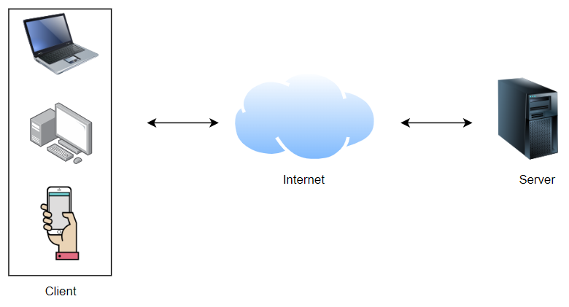

Figure VIII.1Architecture

The client-server architecture over the Internet is a distributed system in which devices (it can be computers, phones or other electronic devices) are connected to each other via the Internet. In this structure, the client is used to request information or services from the server, and the server is used to provide information and services to the client.

When a client sends a request to the server over the Internet, the request is forwarded to the server and the server responds to the request with the requested data or services. A familiar example of a client-server system over the internet is accessing a web page. When the user accesses the website through the browser, the browser acts as the client and requests the web page from the server. The server responds to the request by returning the web page to the browser.

The client-server architecture over the Internet has many advantages such as scalability, availability, remote service provisioning, safety and security assurance and much more. However, this system can also be attacked by attackers, so protection and security is also a significant concern.

## Technology choices

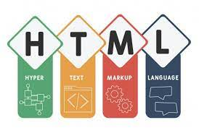**8.2.1 HyperText Markup Language**

Figure VIII.2 html[1]

HTML stands for Hypertext Markup Language - an interpreted programming language used to build web pages. Using elements in HTML, we can create a web page structure that includes text elements, block elements, and headers.

The HTML text element is used to display paragraphs, and can be distinguished from one another by blank lines or markup. Block elements, like <div>, <article>, <table> are also important elements in HTML, helping to separate different sections of the web page and layout them efficiently.

Headers are an integral part of HTML, they are used to contain the headers and subheaders of the web page. HTML provides six heading elements from h1 to h6, where h1 is the main heading element and usually contains the main title of the content.

In a nutshell, HTML is one of the most popular website creation languages, providing basic text, block and header elements to help build beautiful and interactive web pages. (O'Grady, 2022)

**8.2.2 Cascading Style Sheets**

Figure VIII.3 Css[2]

CSS (Cascading Style Sheets) is an extremely important tool in website design. As a designer, you know that not only content but also layout and color management are important. That's where CSS becomes incredibly useful.

While HTML manages the construction of the document's structure including paragraphs, headings, and images, CSS adds style, color, formatting, size, and layout to the web page

An easy way to better understand the role of CSS is to imagine the web page as a person, where HTML will do the job of building the body, while CSS will add style and appearance to it. CSS gives web designers tools to specify colors, fonts, sizes, spacing, and more. of web page elements, ensuring that the web page is presented as intended.

Therefore, CSS plays an extremely important role in creating professional, attractive and easy-to-see websites. It helps your website become more interactive with users and increase the attractiveness of the page. (O'Grady, 2020)

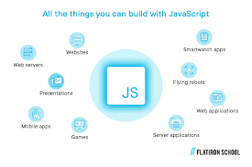**8.2.3 JavaScript**

Figure VIII.4JavaScript[3]

JavaScript is a popular and multifunctional programming language that is used to control many aspects of web pages. It can be used both on the client and server side and allows the creation of dynamic and interactive web pages.

JavaScript allows developers to perform a variety of functions on a web page, including adding animations to images and automatically updating content on the page. This helps the websites become more professional and attractive.

If you have experienced using websites, you will find that JavaScript is an indispensable element in creating interactive web pages. You can easily use its functionality to fill out a form, scroll through a map, or register for an event.

In short, as one of the most popular programming languages today, JavaScript is a powerful tool for creating dynamic and interactive web pages. It helps to increase the dynamism and interoperability of websites and provides developers with more choice and flexibility in the design and implementation of websites. (O'Grady, 2020)

**8.2.4 PHP**

Figure VIII.5 PHP[4]

PHP is a widely used general purpose language and it can be embedded in HTML. This allows developers to create highly interactive websites with ease.

Thanks to its integration with HTML, the PHP language is still widely used and preferred by developers. PHP simplifies HTML code, hides complex technical details, and helps users focus on website development.

In summary, as one of the most popular server-side programming languages today, PHP is an important tool for web developers. It simplifies HTML coding, creates dynamic and interactive web pages, and gives users more choice and flexibility when developing web applications. dynamism and interoperability of websites and gives developers more choice and flexibility in the design and implementation of websites. (Toal, 2017)

8.2.5 Draw.io

Figure VIII.6 Draw.io[5]

Draw.io is a professional and convenient diagram and chart maker for designing and presenting ideas. It is designed to allow users to choose between automatic layouts or create custom layouts making it easier for your ideas to be displayed in the best way. Draw.io offers a wide selection of shapes and hundreds of custom visualizations, allowing your diagram or chart to come through your ideas creatively and uniquely. unique. Drag and drop feature, making the process of creating diagrams or charts easier and simpler than ever. With Draw.io, don't let your ideas be limited by the limitations of the software, instead, convey your ideas in a unique and professional way like never before. (Hope, 2020)

**8.2.6 Ajax**

[6]Figure VIII.7Ajax

AJAX stands for Asynchronous Javascript and XML. It goes from JavaScript functionality to a faster interactive experience. Smoothly processing, adding, or removing dynamic structure on a web page, AJAX keeps track of updated content in real time as visitors interact with functions on the site.

To transport data between the web server and the browser, AJAX uses extensible markup languages (XML) along with other formats such as plain text and JSON.

Combining JavaScript and extensible markup languages, AJAX ensures web page content is updated asynchronously, i.e. web page content can be updated without reloading the entire page. AJAX functions help speed up the website and provide a better user experience, meeting the needs related to interaction and quick data updates. (G., 2022)

## Use case Diagram

### Primary and Secondary Use-case scenario

User

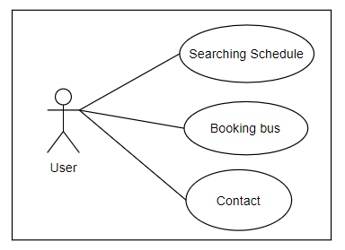

Figure VIII.8 User

In this use case diagram, the user is only enabled to perform two simple yet functional actions. Firstly, the user can enter search information to find a suitable itinerary for their trip. After finding the desired itinerary, the user can proceed with booking a coach ticket to ensure convenience and safety for their journey. Any queries can also be easily addressed by the system through the provided contact information on the website.

Admin

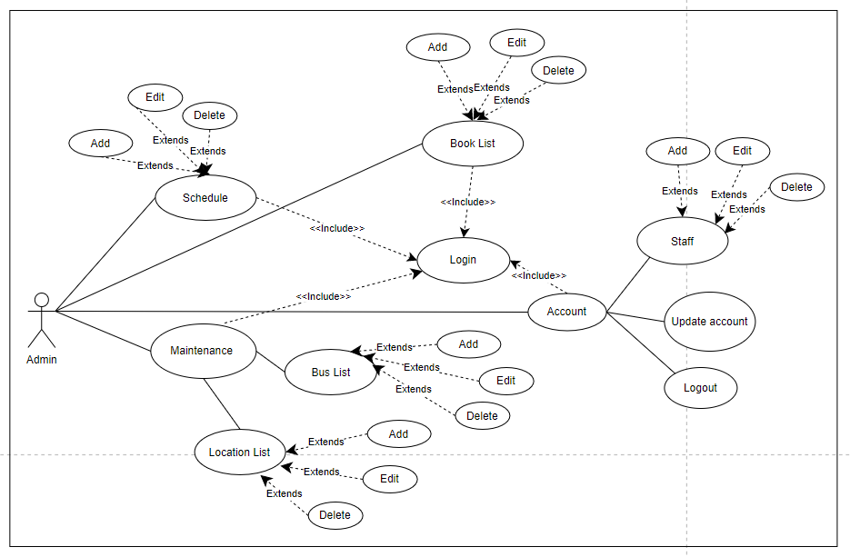

Figure VIII.9 Admin

In the Admin use case diagram, after successful login, the admin can manage various aspects such as Schedule, Booked, Maintenance, and Account. Under the Schedule management section, the admin can Add, Edit, and Delete schedule information. Similarly, in the Booked management section, the admin can perform tasks like adding, editing, and deleting customer information after a successful ticket booking. The Maintenance section is further subdivided into two categories: Location and Bus management, where the admin can add, edit, and delete information related to buses and their locations. Lastly, the Account management section comprises of Staff management, Update account, and Logout tasks. Under the Staff management task, the admin can add, edit, and delete staff information.

**Table 3:** Use case 1.1 Login

|  |  |
| --- | --- |
| **Use Case ID** | UC_1.1 |
| **Use Case Name** | Login |
| **Description** | The user they want to log into the application to use the services from the application. |
| **Actor(s)** | Admin |
| **Priority** | High |
| **Trigger** | User logs in to the website |
| **Pre-Condition(s):** | * Admin account has been created. * The admin account has been authorized. * The admin device is already connected to the Internet when logging in |
| **Post-**  **Condition(s):** | * Admin successfully logged in to the website. * The subscribe button switches to the logout button. |
| **Basic Flow** | 1. User accesses the website. 2. The system will display the login page. 3. User enters account and password and then selects login request. 4. The system authenticates the login information successfully and allow admin to access the website |
| **Alternative Flow** | N/A |
| **Exception Flow** | The system validates the login failed and displays a message. The admin chooses to cancel the login. Use Case stops. |
| **Business Rules** | N/ A |
| **Non-Functional Requirement** | User's password must be hashed with MD5. |

**Table** 4: Use case 1.2 Logout

|  |  |
| --- | --- |
| **Use Case ID** | UC_1.2 |
| **Use Case Name** | Logout |
| **Description** | After admin successfully logs in the system that they want to log out to the current account. |
| **Actor(s)** | Admin |
| **Priority** | Low |
| **Trigger** | Admin can log out after login with the system account. |
| **Pre-Condition(s):** | * The admin device has a network connection. * Admin have logged into the application with the system account. |
| **Post-Condition(s):** | * Admin can successfully log out of the website * "username" switches to the login button. * Sign out button switches to subscribe button. |
| **Basic Flow** | 1. Admin clicks on the logout button. |
| **Alternative Flow** | N/A |
| **Exception Flow** | N/A |
| **Business Rules** | N/A |
| **Non-Functional Requirement** | N/A |

**Table 5:** Use case 1.3 Update profile

|  |  |
| --- | --- |
| **Use Case ID** | UC_1.3 |
| **Use Case Name** | Update profile |
| **Description** | Admin want to update their profile when they have a change |
| **Actor(s)** | Admin |
| **Priority** | Low |
| **Trigger** | Admin want to update profile |
| **Pre-Condition(s):** | * The admin device was connected to the Internet when log in * Admin has logged in to the website |
| **Post-Condition(s):** | Admin successfully logged into the website |
| **Basic Flow** | 1. Admin clicks on the account item. |
|  | 1. Admin clicks Manage Profile. 2. Admin updates information in Profile. 3. Admin clicks Save button to save the update process. 4. The system will check and save the updated information. |
| **Alternative Flow** | N/A |
| **Exception Flow** | The system checks and saves the update failed: 4.c1: Invalid update information Admin rechecked for update Information and correct it. 4.c2: Admin chooses to cancel update ice Use Case stops. |
| **Business Rules** | N/A |
| **Non-Functional Requirement** | N/A |

**Table 6:** Use case 1.4 Search booking bus

|  |  |
| --- | --- |
| **Use Case ID** | UC_1.4 |
| **Use Case Name** | Search bus booking |
| **Description** | User can search item based on certain information/keyword |
| **Actor(s)** | Customer, Admin |
| **Priority** | Medium |
| **Trigger** | Users can search based on certain information/keywords |
| **Pre-Condition(s):** | * The user's device has a network connection. * Users need to login to the website |
| **Post-Condition(s):** | The user has successfully found the specified item in the website. |
| **Basic Flow** | 1. User clicks on the search bar. 2. User enters search keyword. 3. Users click search. 4. The website displays search results to the user. |
| **Alternative Flow** | N/A |
| **Exception Flow** | N/A |
| **Business Rules** | N/A |
| **Non-Functional Requirement** | N/A |

**Table :** Use case View booking bus

|  |  |
| --- | --- |
| **Use Case ID** | UC_1.6 |
| **Use Case Name** | View details booking bus |
| **Description** | Users can view booking details |
| **Actor(s)** | Customer |
| **Priority** | Hight |
| **Trigger** | Users can view booking details |
| **Pre-Condition(s):** | * The user's device has a network connection. * Users need to login to the website |
| **Post-Condition(s):** | Successful users can see booking details |
| **Basic Flow** | 1. User clicks on the product. 2. Website displays detailed booking results for users. |
| **Alternative Flow** | N/A |
| **Exception Flow** | N/A |
| **Business Rules** | N/A |
| **Non-Functional Requirement** | N/A |

**Table :** Manage schedule

|  |  |
| --- | --- |
| **Use Case ID** | UC_2.1 |
| **Use Case Name** | Manage Schedule |
| **Description** | Administrators can manage schedule |
| **Actor(s)** | Admin |
| **Priority** | Hight |
| **Trigger** | Administrators can manage products |
| **Pre-Condition(s):** | * The administrator's device has a network connection. * The administrator needs to log into the site with an administrator account |
| **Post-Condition(s):** | Admin can successfully manage the product |
| **Basic Flow** | 1. Login by admin account 2. Admin click "Schedule" tab   3.The website displays the product management page and admin can add update or delete schedule |
| **Alternative Flow** | N/A |
| **Exception Flow** | * Adding: The error message will display when admin enters information of schedule with invalid constraint. Adding schedule is not successfully. * Updating: The error message will display when admin updates schedule with invalid information. Updating schedule is not successfully. * Deleting: The admin chooses to cancel the deleting. Deleting schedule is not successfully. |
| **Business Rules** | N/A |
| **Non-Functional Requirement** | N/A |

**Table :** Manage booked list

|  |  |
| --- | --- |
| **Use Case ID** | UC_2.2 |
| **Use Case Name** | Manage Booked List |
| **Description** | Administrators can manage booked list |
| **Actor(s)** | Admin |
| **Priority** | High |
| **Trigger** | Administrators can manage booked list |
| **Pre-Condition(s):** | * The administrator's device has a network connection. * The administrator needs to log into the site with an administrator account |
| **Post-Condition(s):** | Admin can successfully manage booked list |
| **Basic Flow** | 1. Admin click " Booked List " button 2. The website displays the booked list management page and returns it to the administrator. |
| **Alternative Flow** | N/A |
| **Exception Flow** | * Adding: The error message will display when user enters information of product with invalid constraint. Adding category is not successfully. * Updating: The error message will display when user updates booked list with invalid information. Updating booked list is not successfully. * Deleting: The user chooses to cancel the deleting. Deleting booked list is not successfully |
| **Business Rules** | N/A |
| **Non-Functional Requirement** | N/A |

**Table :** Manage bus list

|  |  |
| --- | --- |
| **Use Case ID** | UC_2.2 |
| **Use Case Name** | Manage Bus List |
| **Description** | Administrators can manage bus list |
| **Actor(s)** | Admin |
| **Priority** | High |
| **Trigger** | Administrators can manage bus list |
| **Pre-Condition(s):** | * The administrator's device has a network connection. * The administrator needs to log into the site with an administrator account |
| **Post-Condition(s):** | Admin can successfully manage booked list |
| **Basic Flow** | 1. Admin click the Maintenance tab. 2. Admin click " Bus List " button 3. The website displays the bus list management page and returns it to the administrator. |
| **Alternative Flow** | N/A |
| **Exception Flow** | * Adding: The error message will display when user enters information of product with invalid constraint. Adding bus list is not successfully. * Updating: The error message will display when user updates bus list with invalid information. Updating bus list is not successfully. * Deleting: The user chooses to cancel the deleting. Deleting bus list is not successfully |
| **Business Rules** | N/A |
| **Non-Functional Requirement** | N/A |

**Table :** Manage location list

|  |  |
| --- | --- |
| **Use Case ID** | UC_2.2 |
| **Use Case Name** | Manage Location List |
| **Description** | Administrators can manage location list |
| **Actor(s)** | Admin |
| **Priority** | High |
| **Trigger** | Administrators can manage location list |
| **Pre-Condition(s):** | * The administrator's device has a network connection. * The administrator needs to log into the site with an administrator account |
| **Post-Condition(s):** | Admin can successfully manage booked list |
| **Basic Flow** | 1. Admin click the Maintenance tab. 2. Admin click " Location List " button 3. The website displays the bus list management page and returns it to the administrator. |
| **Alternative Flow** | N/A |
| **Exception Flow** | * Adding: The error message will display when user enters information of product with invalid constraint. Adding location list is not successfully. * Updating: The error message will display when user updates location list with invalid information. Updating bus list is not successfully. * Deleting: The user chooses to cancel the deleting. Deleting bus list is not successfully |
| **Business Rules** | N/A |
| **Non-Functional Requirement** | N/A |

**Table :** Manage staff

|  |  |
| --- | --- |
| **Use Case ID** | UC_2.4 |
| **Use Case Name** | Manage staff |
| **Description** | Admin can manage staff |
| **Actor(s)** | Admin |
| **Priority** | Hight |
| **Trigger** | Admin can manage staff |
| **Pre-Condition(s):** | * The administrator's device has a network connection. * The administrator needs to log into the site with an administrator account |
| **Post-Condition(s):** | Admin can successfully manage users |
| **Basic Flow** | 1. Admin login with admin account 2. Admin click the Admin tab. 3. Admin click "Manage Staff" button 4. The website displays the users management will display and admin can update user information |
| **Alternative Flow** | N/A |
| **Exception Flow** | * Adding: An error message will be displayed when the administrator enters invalid binding customer information. Add client failed. * Update: An error message will be displayed when the user updates the customer with invalid information. Client update failed. * Delete: The administrator chooses to cancel deletion. Delete user menu failed |
| **Business Rules** | N/A |
| **Non-Functional Requirement** | N/A |

## Entity Relationship Diagrams

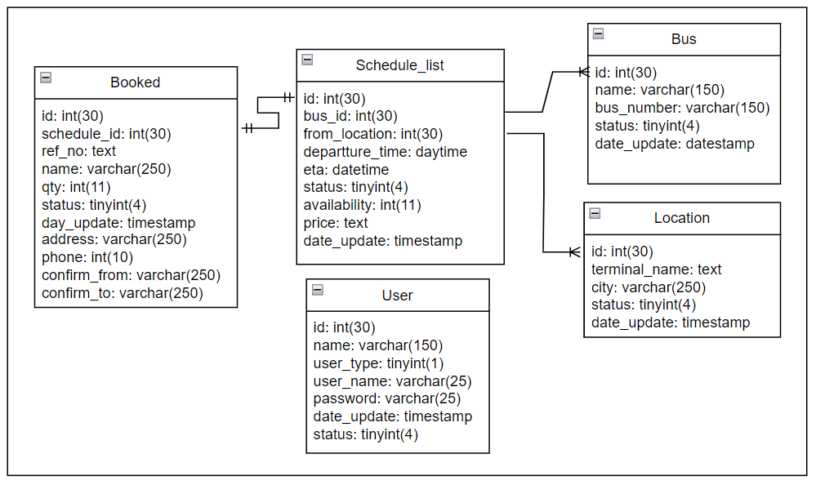

Entity Relationship Diagrams

The Schedule table and the Bus table are two entities with a 1-to-many relationship. A bus trip will be planned through the Schedule table, while each of these buses will be used by many different customers. Therefore, the Schedule table and the Bus table will have a 1-to-many relationship, where the Bus table will be linked to the Schedule table by a foreign key. Specifically, each record of the Schedule table will have a field associated with the primary key field of the Bus table, allowing transparent and efficient management of information about trips and transit center.

The Schedule and Location tables also have a 1-to-many relationship. Each bus trip will be connected to a departure and destination location on the Schedule table. Meanwhile, each location will have many different buses passing through. This shows, the Schedule table and the Location table will be linked together through a 1-to-many relationship, in which the Location table will be linked by a foreign key to the Schedule table. Each record on the Schedule table will have a field that links to the Location table, allowing for more efficient management of trip and location information. This linkage will help bus managers to quickly find location information and plan operations conveniently and accurately.

The Schedule table and the Booked table are two entities with a one-to-one relationship. Each bus trip will have a schedule planned by the manager through the Schedule table. When customers book tickets, their information will be stored on the Booked table, with each trip having only one corresponding record on the Booked table. Similarly, each record on the Booked table will be connected to a record in the Schedule table, ensuring that the trip and customer information are correctly linked. The link between the Schedule table and the Booked table makes it easier to manage bus tickets, saving time and increasing accuracy in information processing.

## Wireframes for prototypes

This is home page when user to access

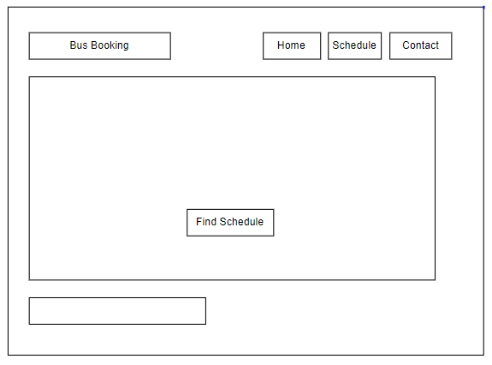

This is page use after find schedule

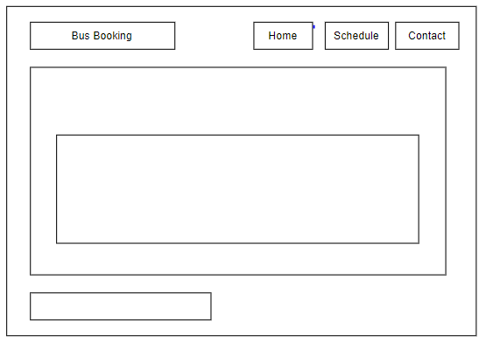

This is page admin login

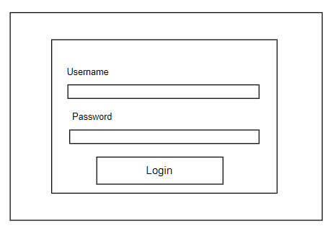

This is page admin manage website

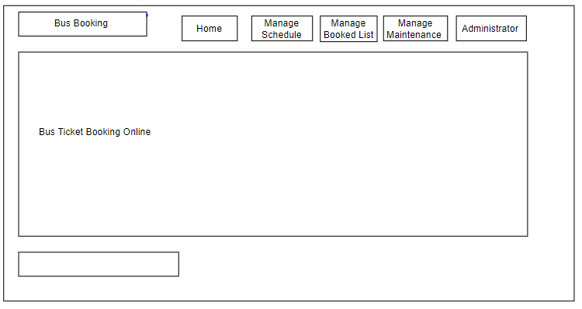

This is page Manage Schedule

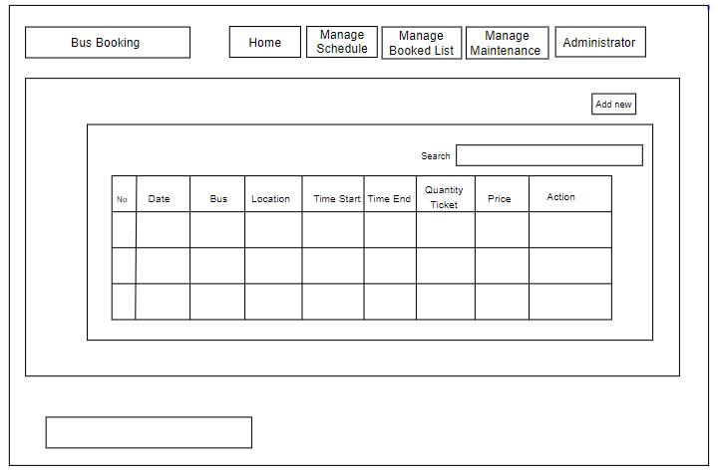

This is page Manage Booked List

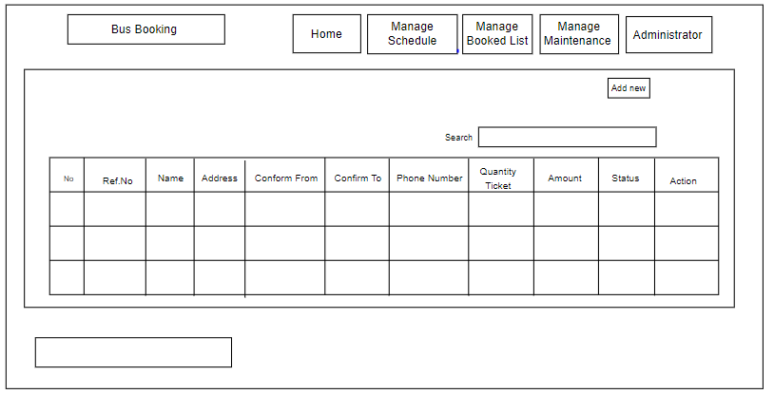

This is Manage Bus

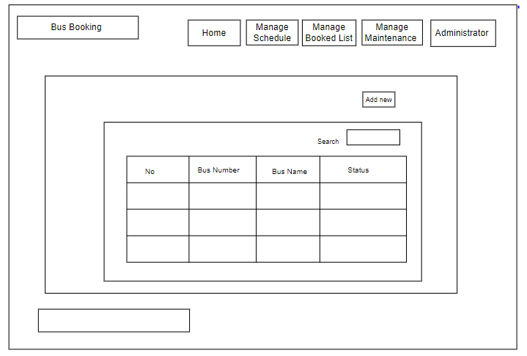

This is Manage Location

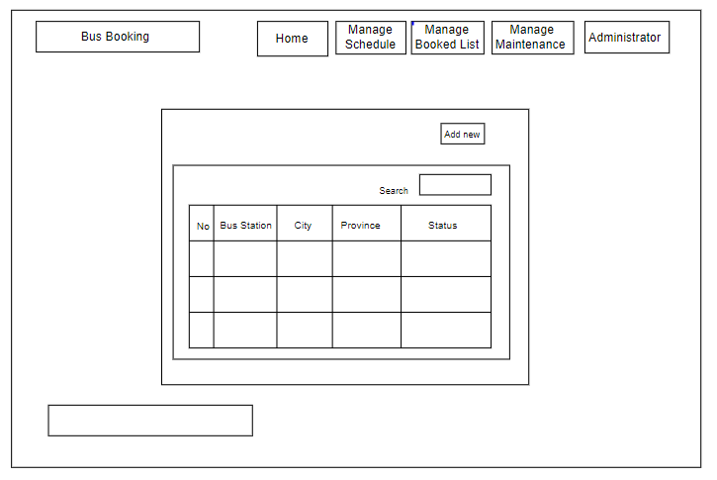

This is page Manage Staff

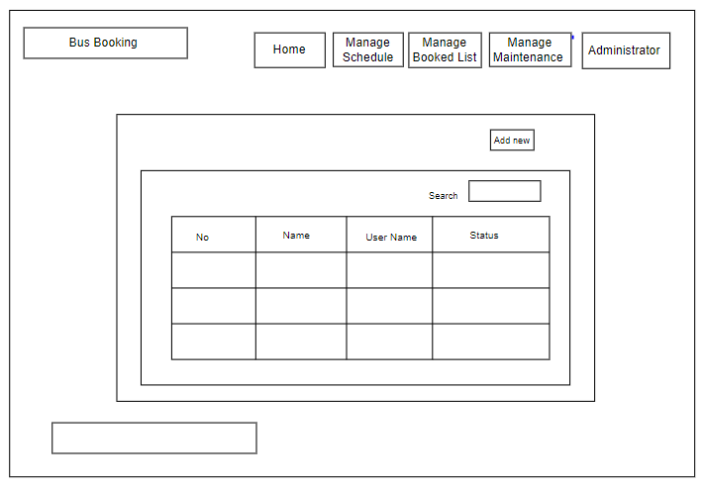

This is page Manage Account

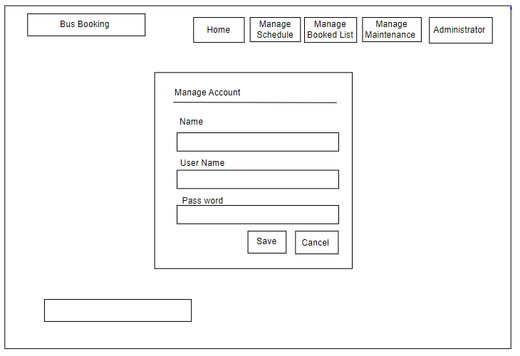

## Site Maps

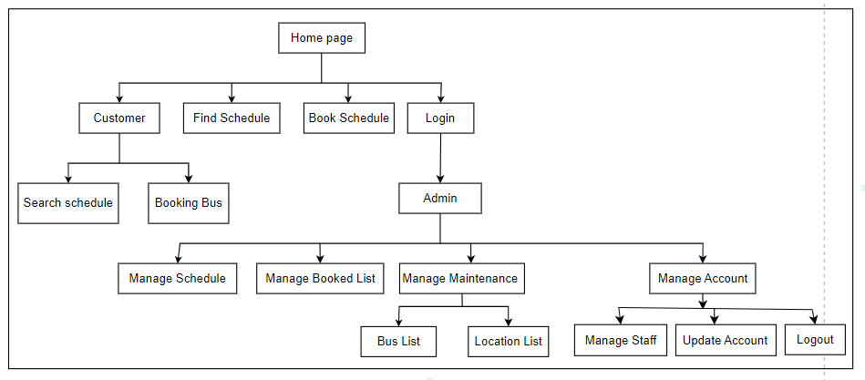

Site Maps

This is the overall diagram for the bus ticketing system, depicting the main parts of the system. Each part has a distinct function. The first part is designed to give users (customers) a full online experience, allowing them to easily search for schedules and book tickets. The second part is designed to assist administrators in managing the system, allowing them to control and process information about Schedule, Booked List, Location, Bus and Account. These two parts are combined to create a full experience for customers and administrators, making the management of information related to bus tickets more efficient and convenient.

## Activity Diagram / Sequence Diagram

User

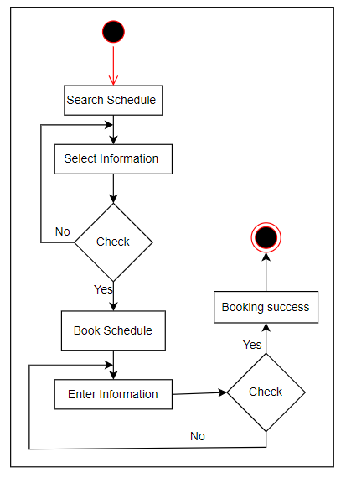

First, the user (customer) will search for the schedule information of a vehicle. Then the user will enter the information he needs to find when, after entering the information, the system will now check if the user's schedule is available or not, if not, the system will notify and let the user know. re-enter, if the information is available, the user will select and book the ticket. Next, the user will enter the necessary information to proceed with booking a bus ticket, after the user has entered all the information and proceeded to book the ticket, the system will check to see if the user has not entered enough information. The system will not allow booking and let the user reload and fill in the information completely, and if the information is complete, the system will notify the user to book a successful ticket.

Admin

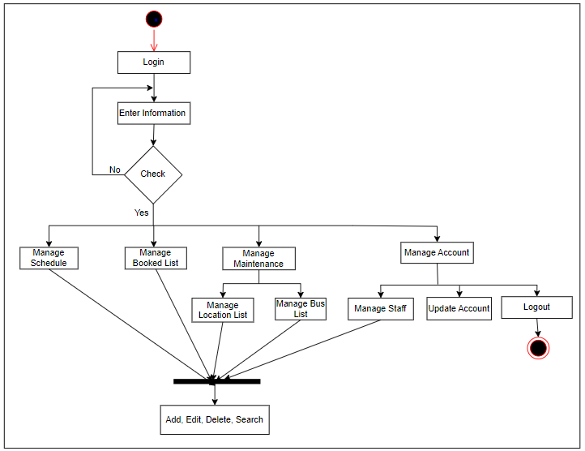

To access the system administrator, the administrator must first log in. If the user has to enter the login information and press login, the system will check if the account is correct, if it is wrong, the system will notify and re-enter the login information, and if it is correct, The system will display the administrator's management section.

# Implementation

## Database

In this Data section I use phpMyadmin to create a database for my system. To create data first go to phpMyadmin, then select New to create a database.

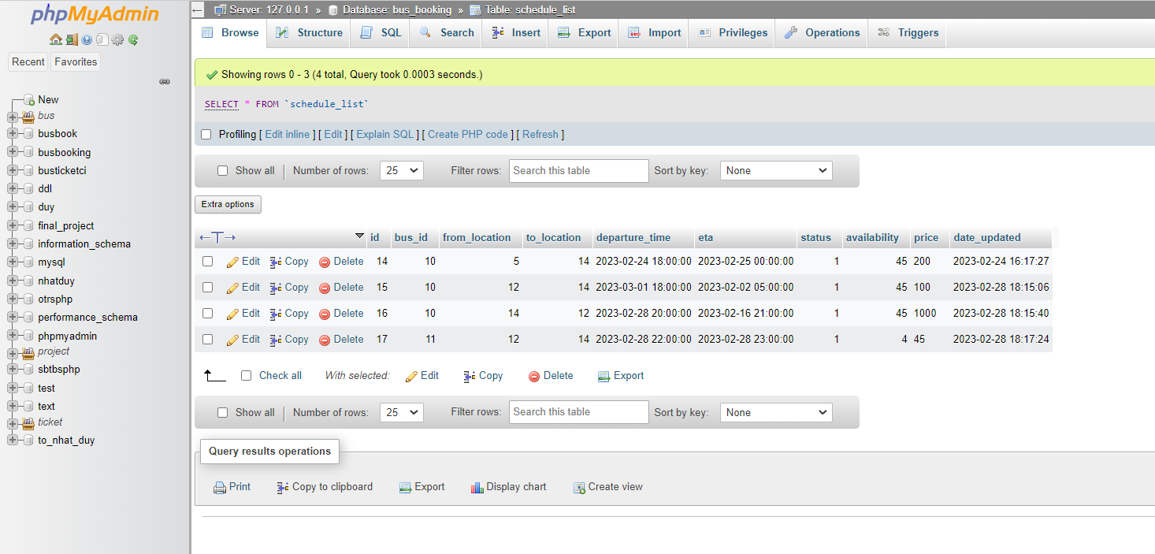

After clicking on new, next we will enter the database name, after entering, click Create to create the database.

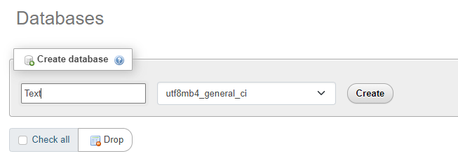

After creating the database, the next step is to create a table for the database. In creating a table, you need to enter the name of the table and the number of columns of that table and click Create to create the table.

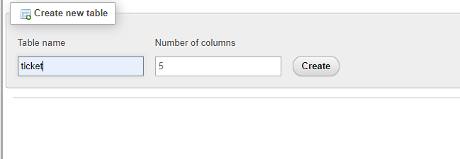

Next we will create the number of attributes equal to the number of columns of the table. In this section we will name the property, choose the data type for that property and the value of that property. Then click Save to proceed to create the properties of that table.

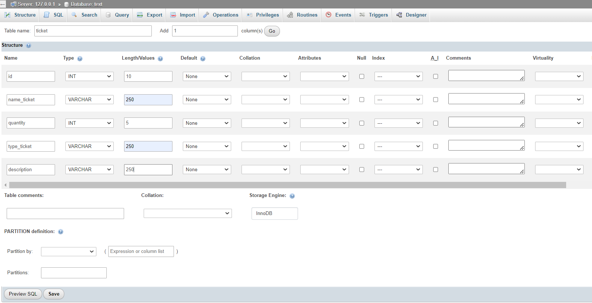

Finally, the system will display the table, the number of columns, the number of attributes along with the data type and value of that attribute.

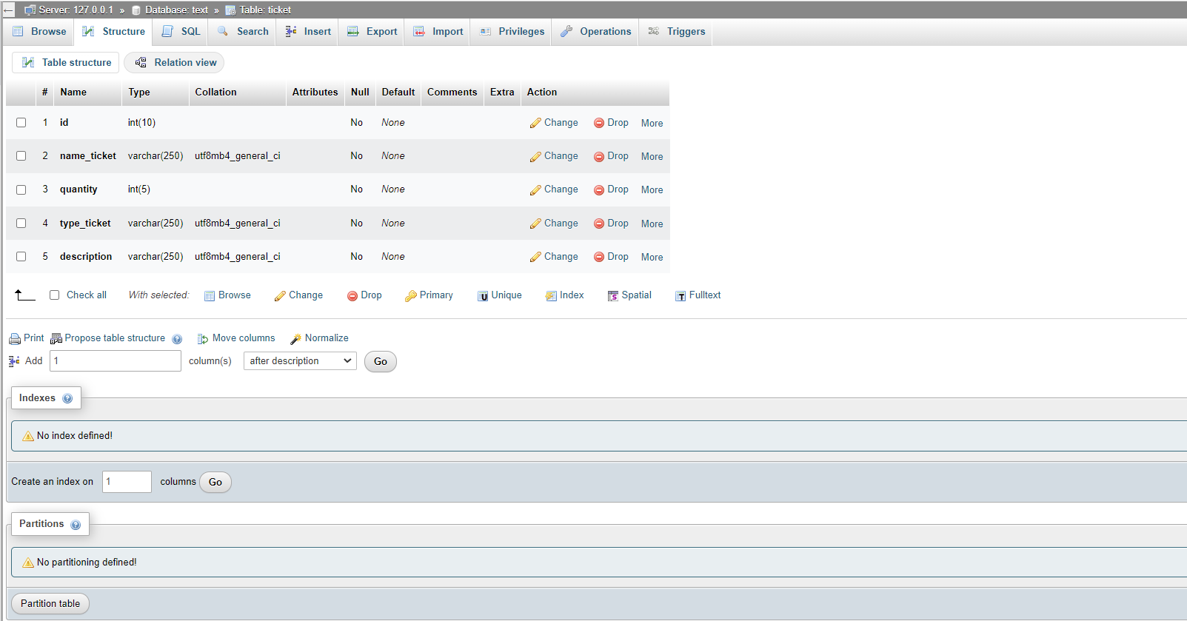

## Front End

* + 1. Html

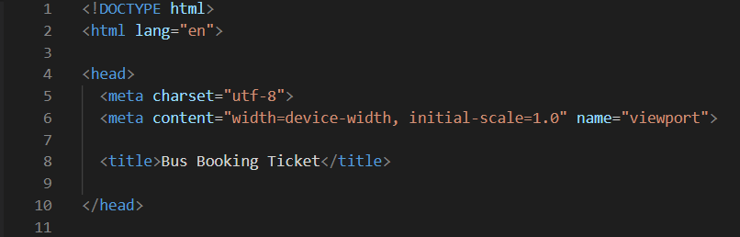

In the website, HTML has been used to create the title for the system, making it easy for users to recognize and distinguish between different parts of the website. In addition, HTML is also used to create a uniform template for data entry, ensuring consistency and synchronization in data customizations.

The use of HTML helps users to better understand the structure and content of the website, supports the faster loading of the website, and also creates convenience and saves time for users. programmers in the management and maintenance of websites.

* + 1. Css

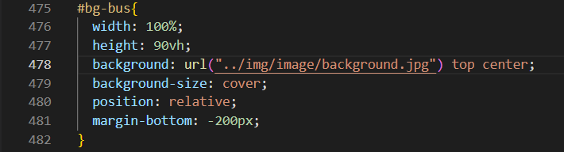

In the website system, CSS was used to format the interface of the website. This is a very useful tool to create beautiful and aesthetically pleasing websites. Thereby, users can easily access the content on the website, and create a better experience for users.

For each element on the web page, CSS provides different properties that can be adjusted to suit the intended use of the web page. These properties allow users to customize the color, font, font style, size, and spacing of elements on the page to make the web page more readable and intuitive.

## Back End

* + 1. PHP

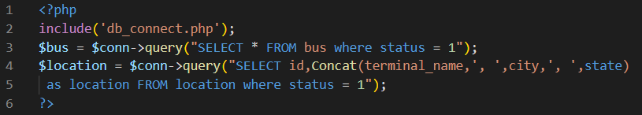

These functions are very important in the data management system and allow users to manipulate the database directly. Through these functions, users can add new data, update information, delete unnecessary data or extract data for external manipulation.

PHP also allows developers to build more complex database management systems. We can control access to the database, ensure the security and protection of the data, and manage and optimize the database.

* + 1. Ajax

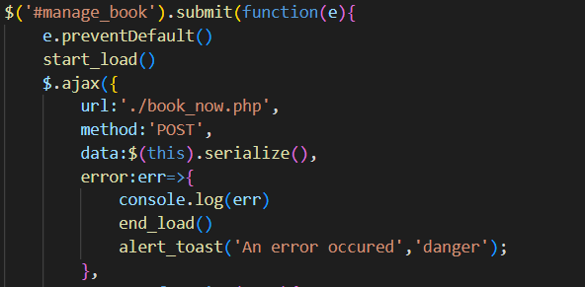

In the web system, Ajax has been used to save data from forms through the POST method. When the user enters information and submits the form, Ajax will send the data information to the server through the POST method to save the entered information.

Using Ajax makes the website faster and more responsive to users. Since there is no need to reload the entire page every time it is requested, it also saves bandwidth and reduces page load time, creating a better online experience for users.

* + 1. Javascript

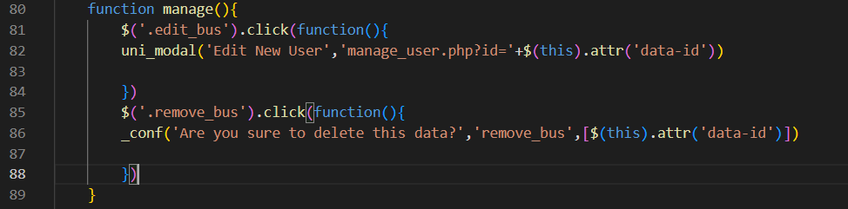

In the system, JavaScript was used to create the notification form for the user. When a user performs an action on the web page, JavaScript generates notification forms to provide activity information related to that action.

Using JavaScript to create forms helps users understand the activities that are happening on the website. Through notification forms, users can confirm or cancel requests or change some options on the page.

## Images

This is the home page when you visit the website.

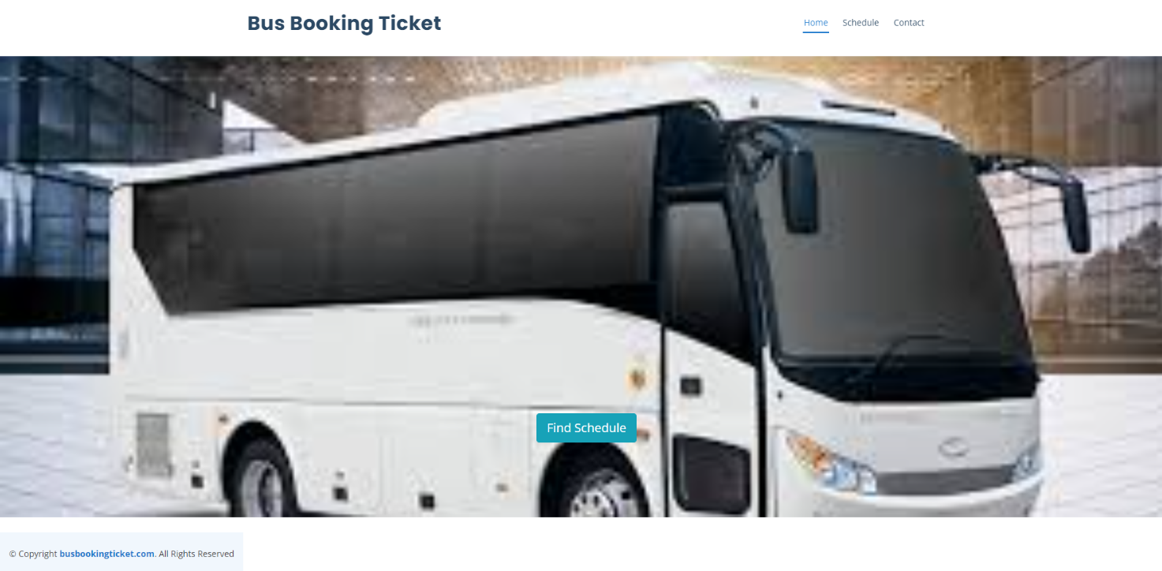

This is a trip schedule search page that meets the needs of users. When you click the Find Schedule button, the website automatically displays an easy-to-use form for you to enter information about your trip. With the smart search feature, the site will help you find the best schedule with accurate and fast results. You just need to enter basic information about your origin and destination, and the website will automatically process the data to display the trip schedule that best suits your needs.

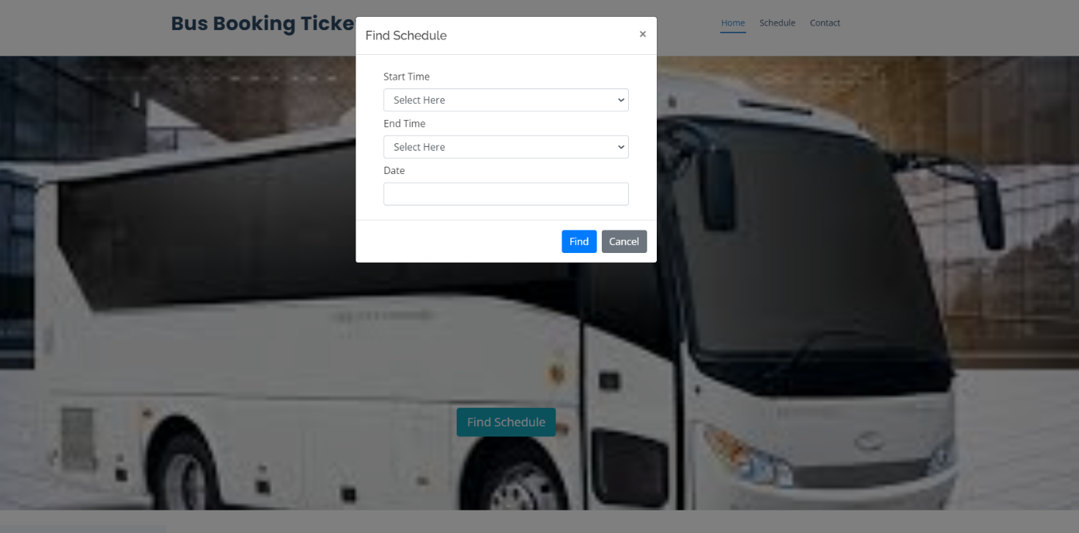

Once you've entered your trip information into the form and pressed the Search button, the site will automatically process and search for matches. If the information you provide matches or matches the data on the website, the system will display the most accurate and relevant search results for your request. From there, you can easily select and refer to the search results to schedule your trip easily and conveniently.

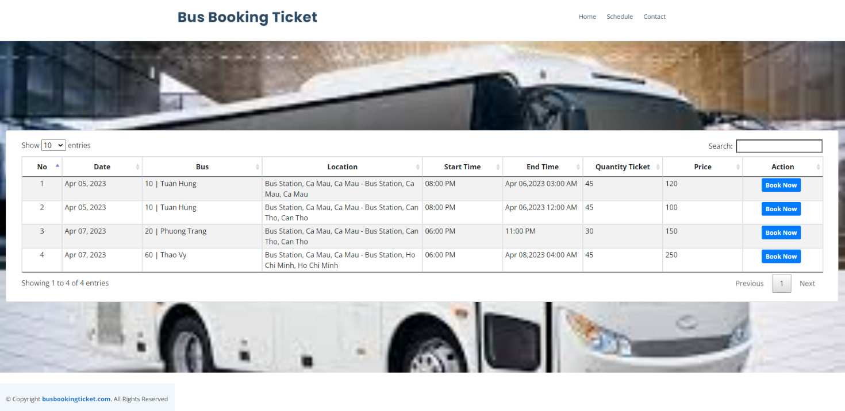

In the event that the information entered by the user does not match or resemble any data on the website, the system will provide a notification indicating that no results were found. This feature serves as a gentle reminder to inform the user that their search did not yield any relevant data.

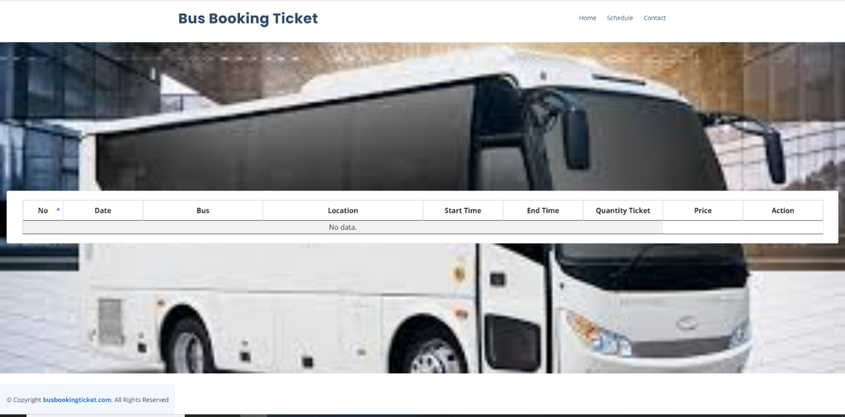

This is the schedule page, in this website it will display information about the bus location, date, time, price, quantity. If the user wants to book a bus ticket, he needs to click on the Book button.

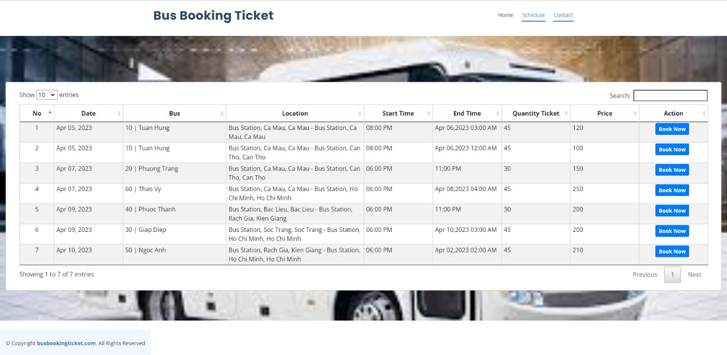

This will be a form for users to enter their information to proceed with booking bus tickets. This form will be displayed when the user clicks the Book button, and if the user has finished entering the information and pressed the Book button on the form, the ticket will be booked.

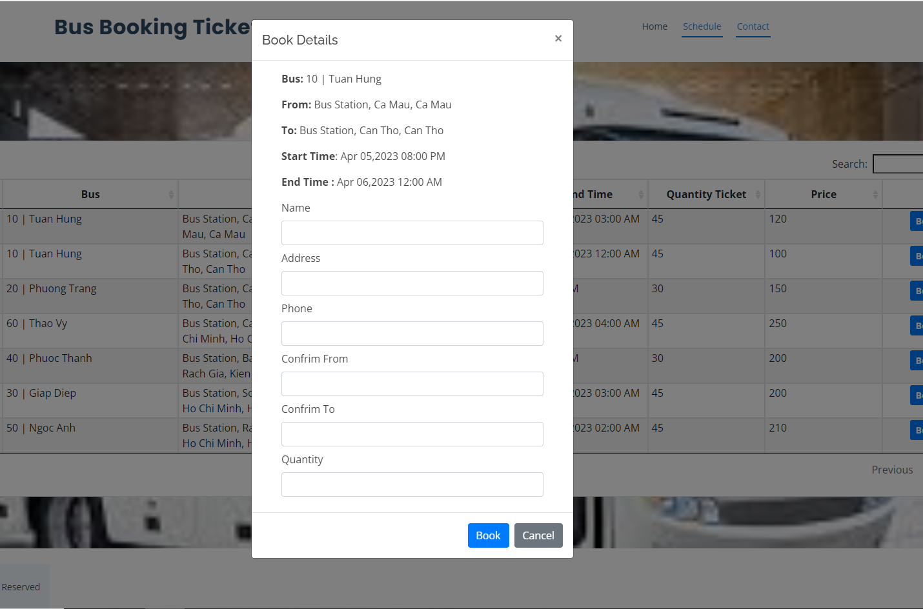

After the user has entered the information and clicked the Book button, the system will store the information the user has booked and the website will display a series of natural numbers representing the ticket number that the user has booked.

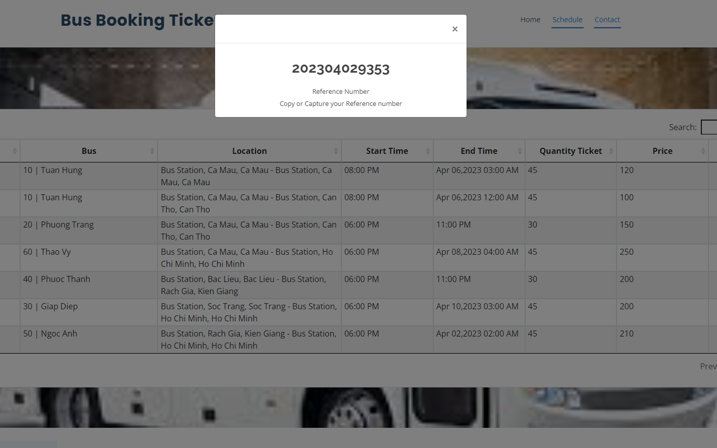

And this will be the contact page, in this website will display the website's information such as: address, phone number, email. so that users can contact the website when there is an unexpected job.

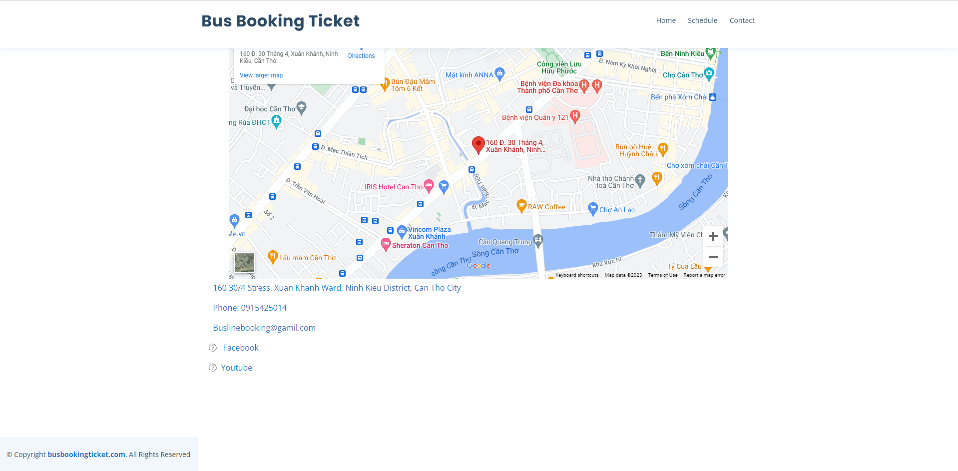

This is the login page for the administrator who wants to access the website administration part of the system. The administrator will have to enter his/her information to proceed into the system.

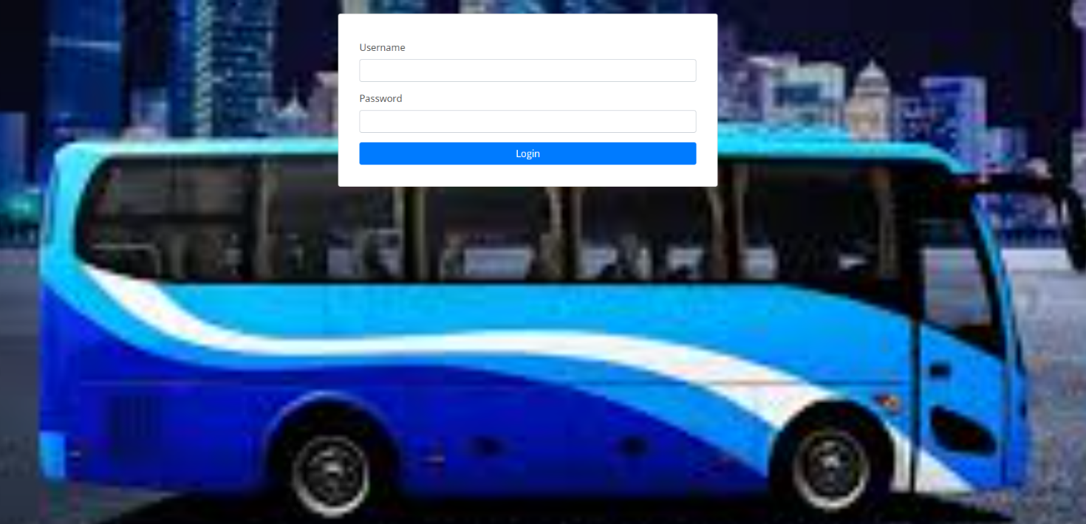

If the administrator enters the wrong Username or Password information, the system will notify and ask the administrator to login again.

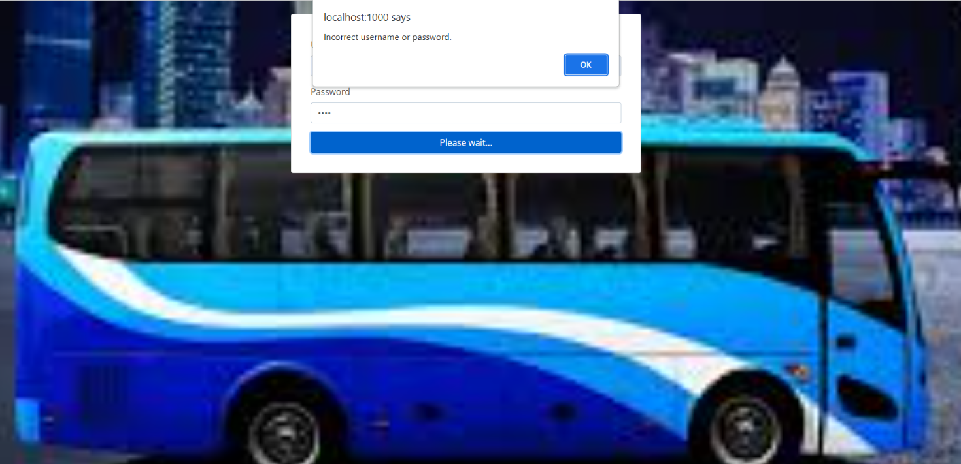

After the administrator has logged in, the system will take the administrator to the management page for the administrator.

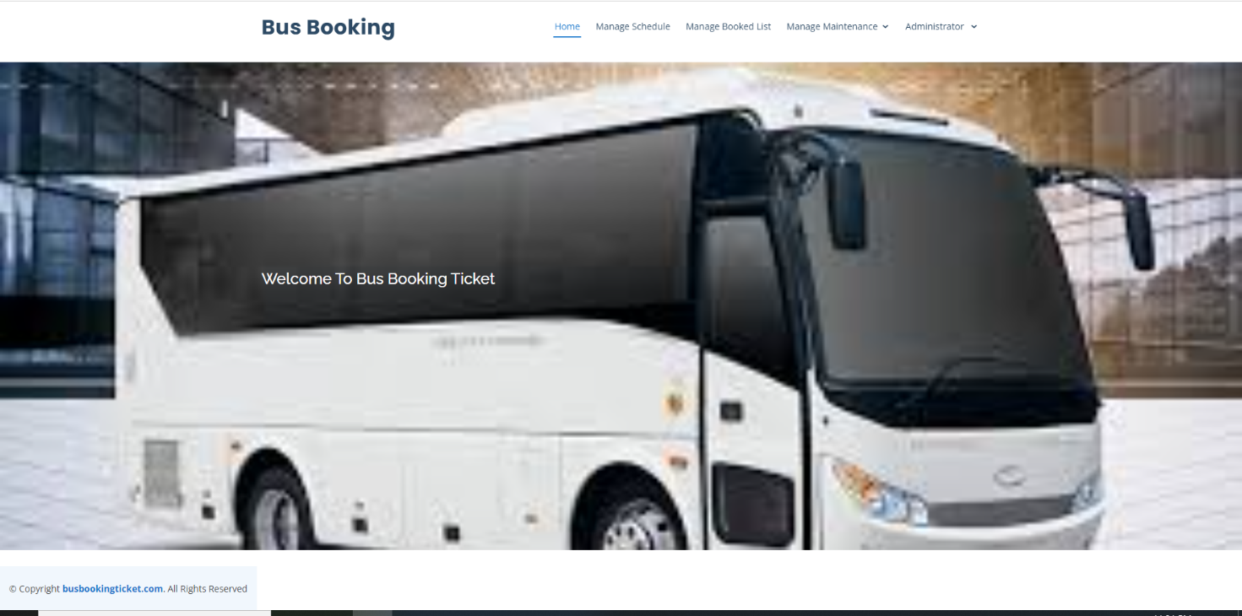

The first part about the administrator's management will be the Manage Schedule page. In this page will be the entire schedule information of all bus trips. In this page admin can add, edit, delete schedule.

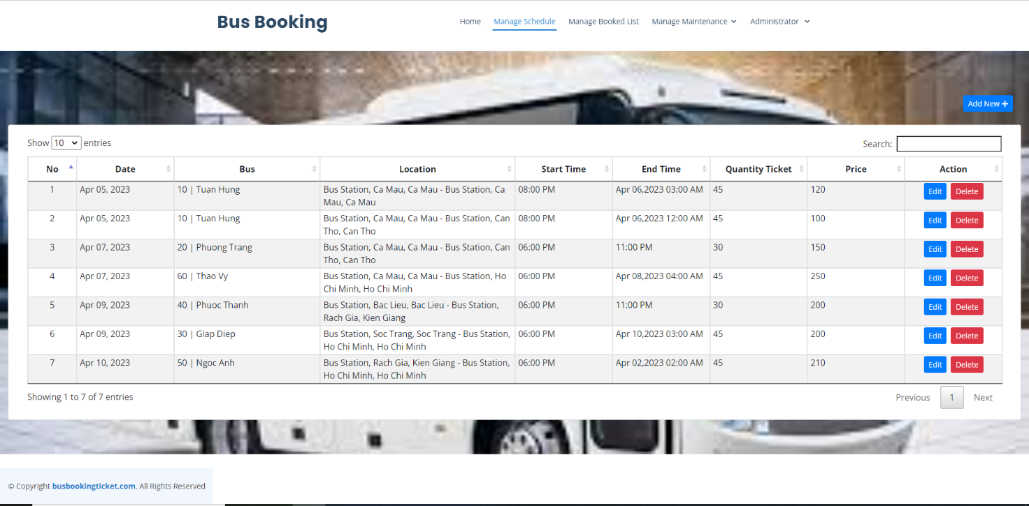

If the administrator wants to add a schedule in this page, he needs to click the Add button to proceed with adding a new schedule. After clicking on the add button, the system will give a form for the administrator to enter the information of the new schedule. If the schedule information has been entered, the administrator needs to click the Save button to proceed with adding data to the database.

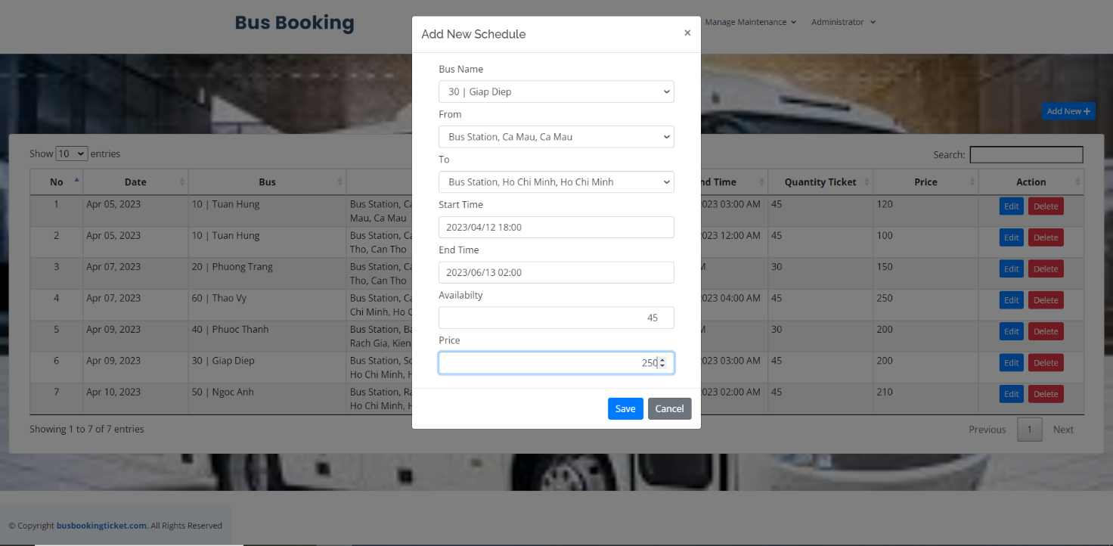

After clicking the Save button, the data is added to the database and the system will display a notification and schedule information that has just been added by the administrator.

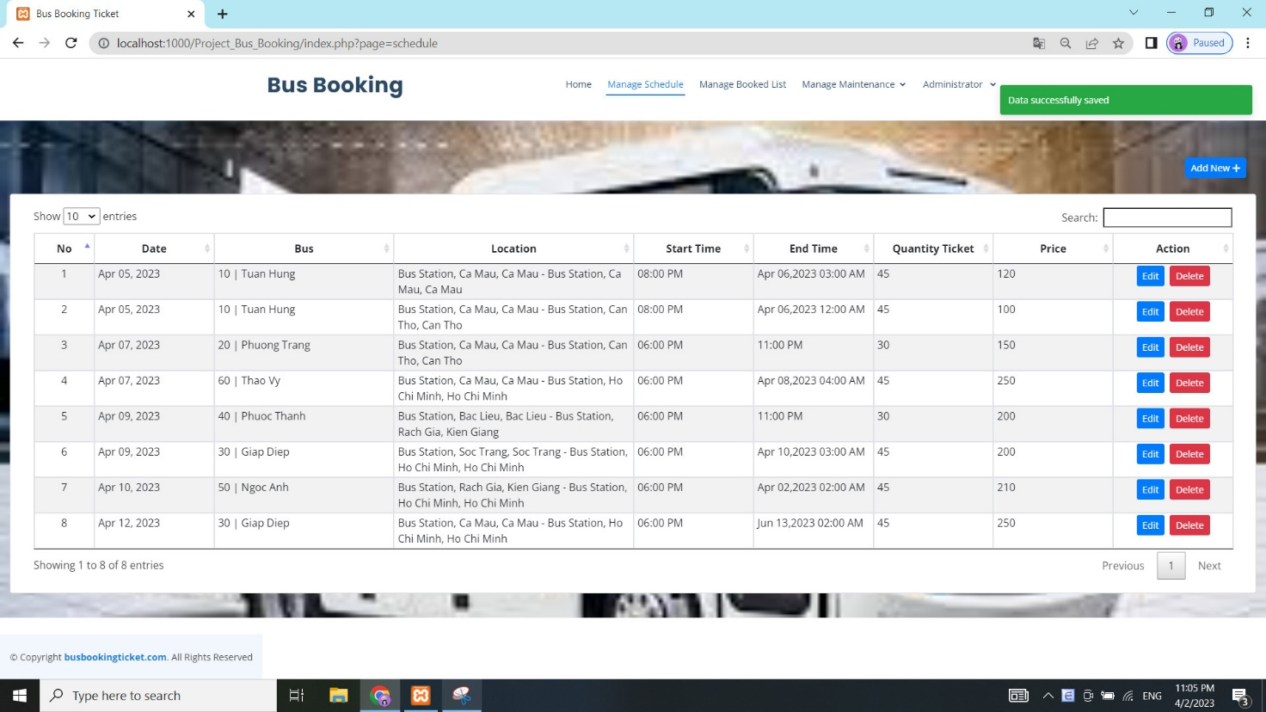

If the administrator wants to edit the schedule information, then click the Edit button to proceed to edit the schedule information. After clicking the Edit button, the system will display the schedule information that the administrator wants to edit.

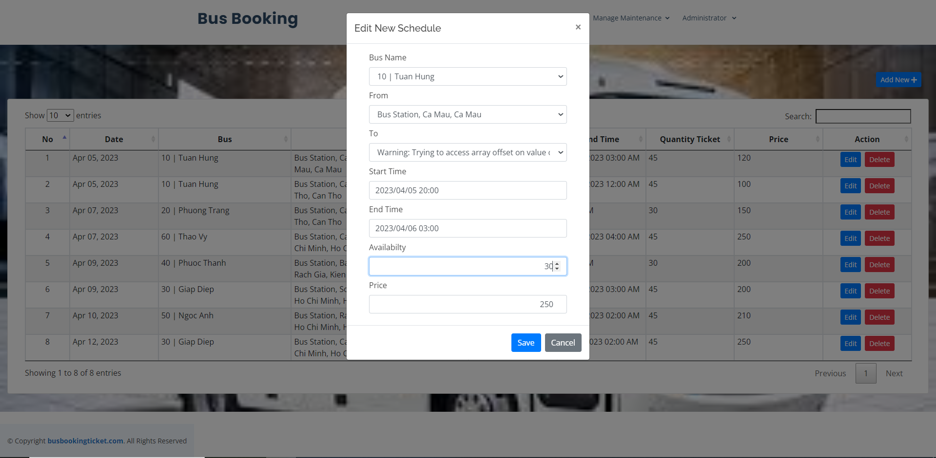

After the administrator has edited the schedule information that he wants, then the administrator needs to click the Save button to proceed to save the edited information. This information will be updated into the database by the system, and the system will display the message and the revised schedule information.

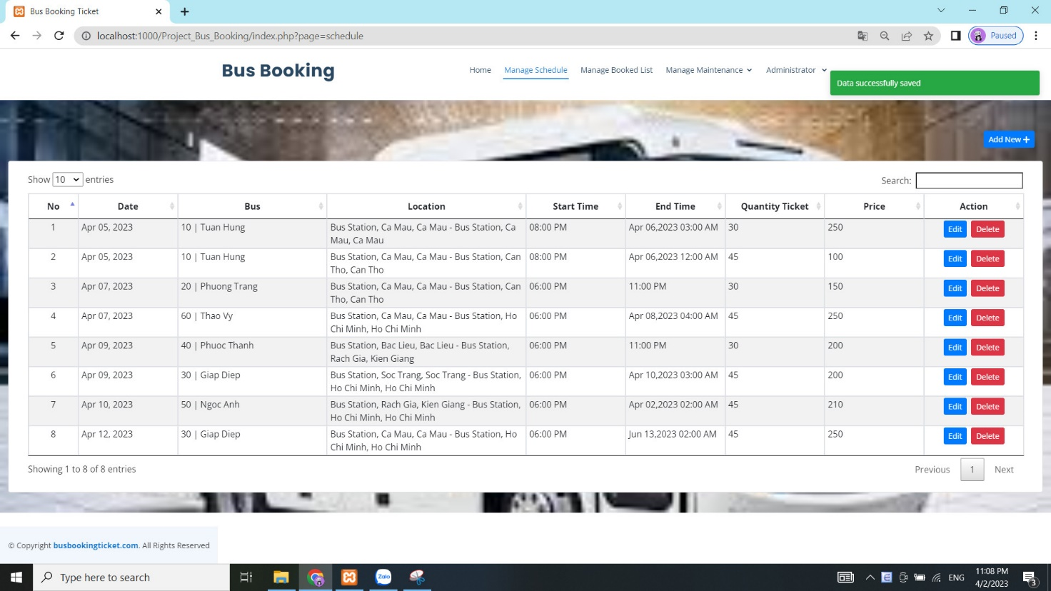

If the administrator wants to delete a certain schedule, click the Delete button there to proceed with the deletion. After clicking the Delete button, the system will display a message that the administrator is sure to delete. If you want to delete click the Ok button, otherwise, if you don't want to delete, click the Cancel button.

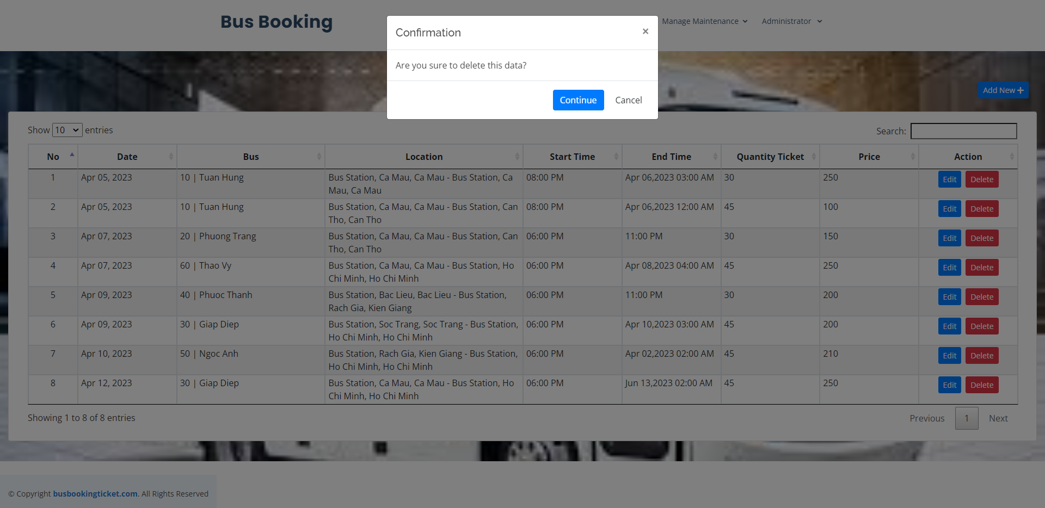

If the administrator wants to delete the schedule and clicks a few Ok buttons, the system will delete that schedule data in the database and display a message telling the administrator that the deletion is complete.

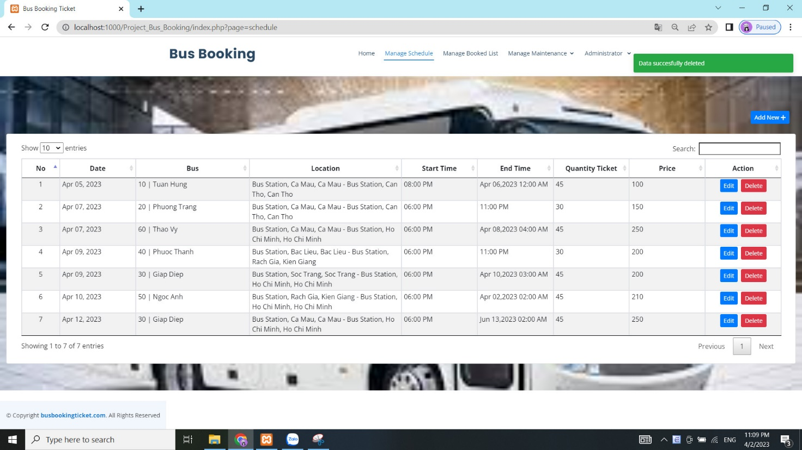

Next in the admin section for administrators will be Manage Booked List. In this page, the system will display information about customers (users) who book bus tickets. In this page, the administrator will have the functions to edit and delete customer information.

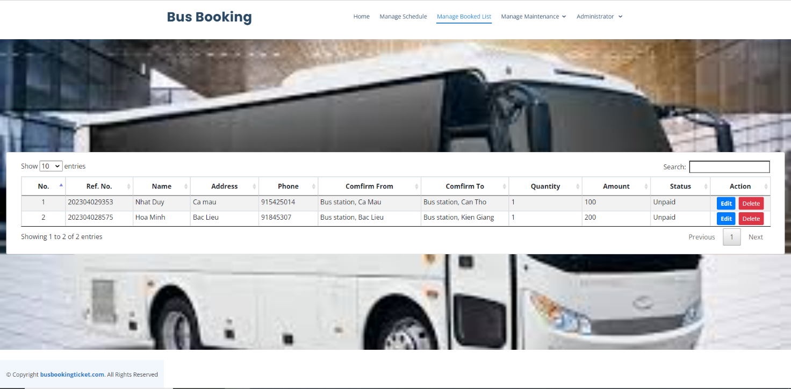

If the administrator wants to edit the customer's information, then click the edit button to proceed with the editing. After clicking the Edit button, the system will display the customer information that the administrator wants to edit. After editing the information, the administrator needs to click the Save button to proceed to save the customer information.

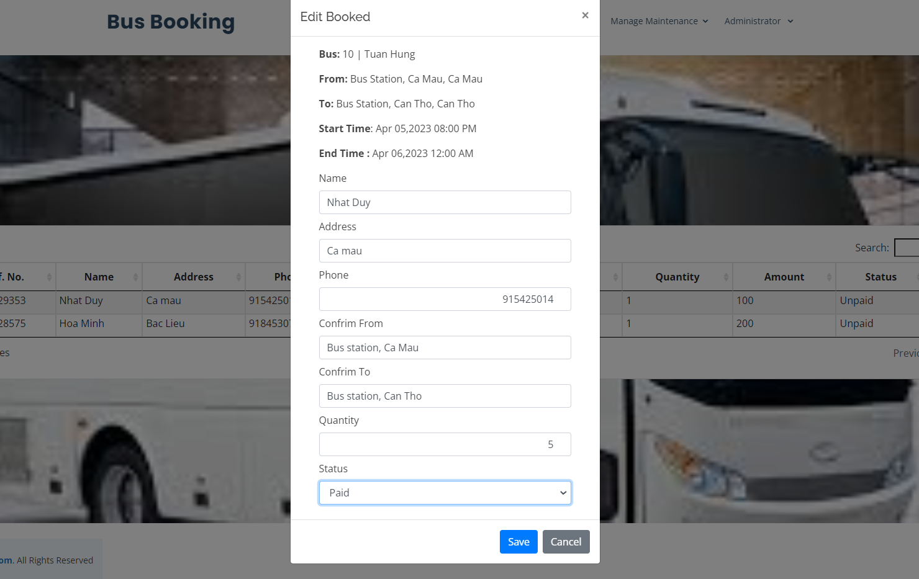

After clicking the Save button, the system will store the data in the database and the system will display a notification to the administrator that the customer information has been updated successfully.

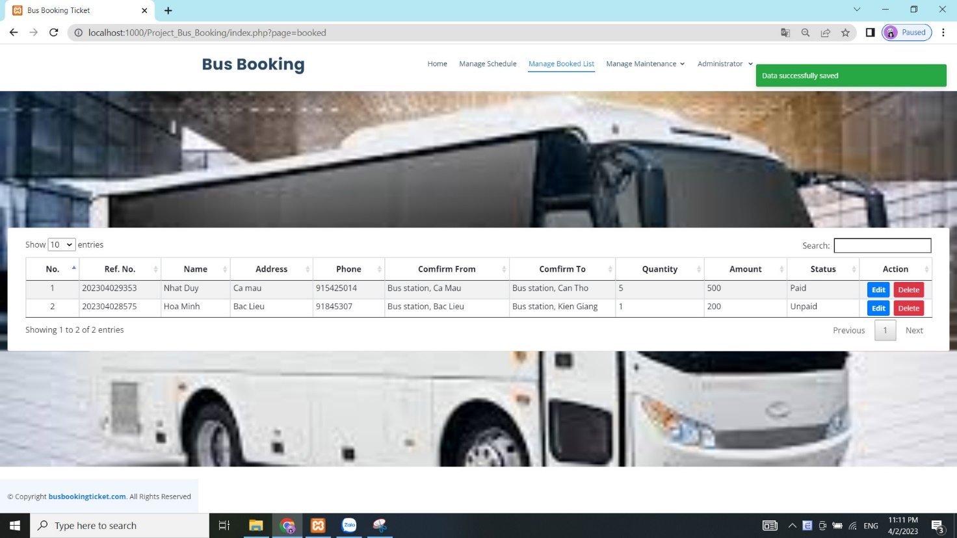

If the administrator wants to delete customer information for booking bus tickets, click the Delete button. After clicking the Delete button, the system will notify that the administrator wants to delete. If you want to delete, click the Ok button and if you want to go back, click some Cancel buttons.

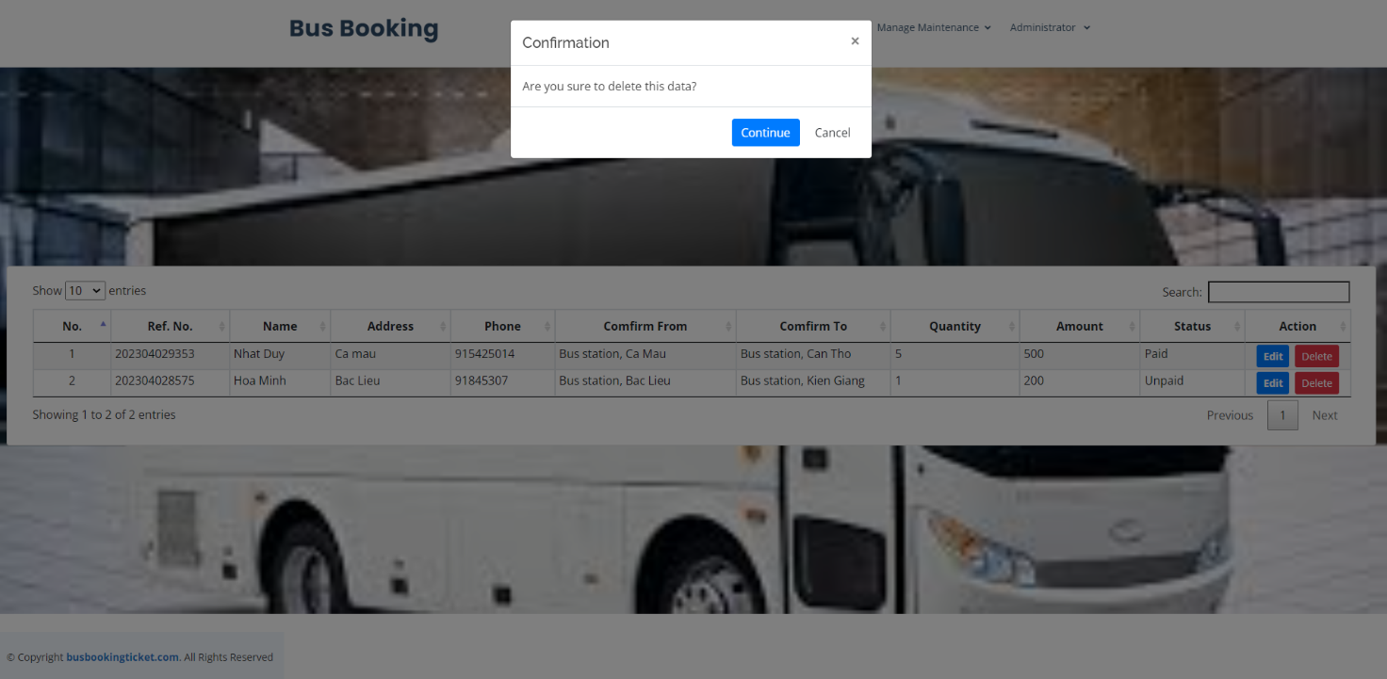

After the administrator wants to delete and clicks the Ok button, the booking customer's data is deleted by the system in the database and displays a successful deletion message to the administrator.

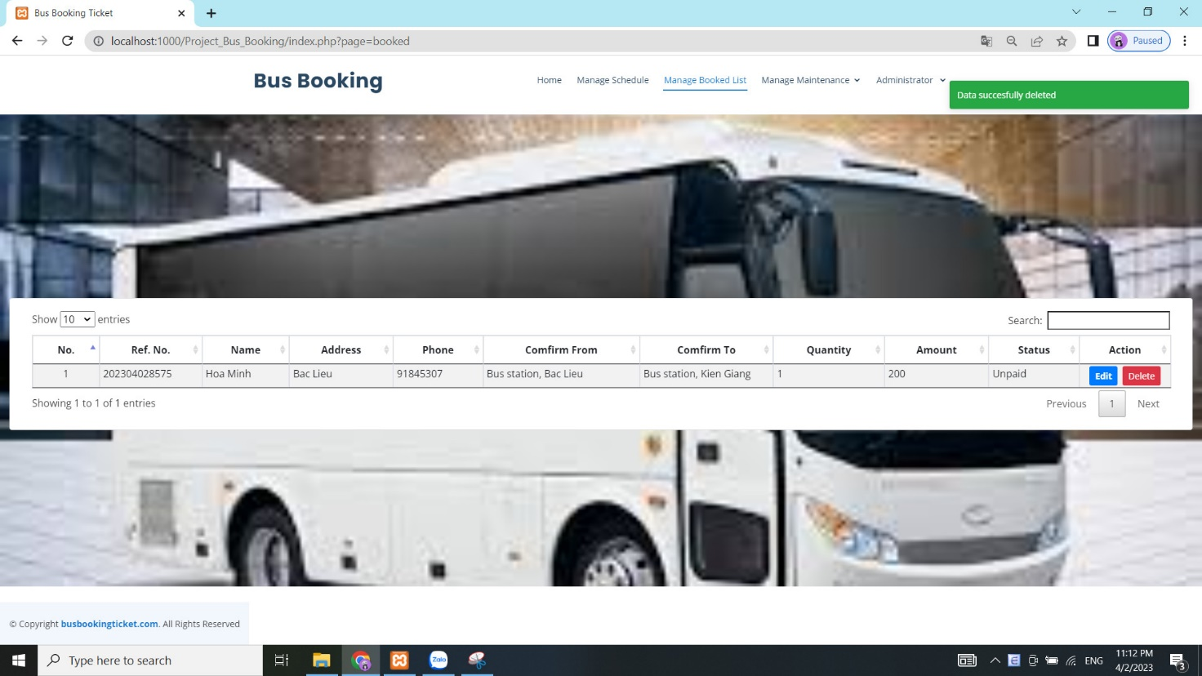

Next in the admin section for administrators will be Manage Bus List. In this page, the system will display information about bus. In this page, the administrator will have the functions to edit and delete bus information.

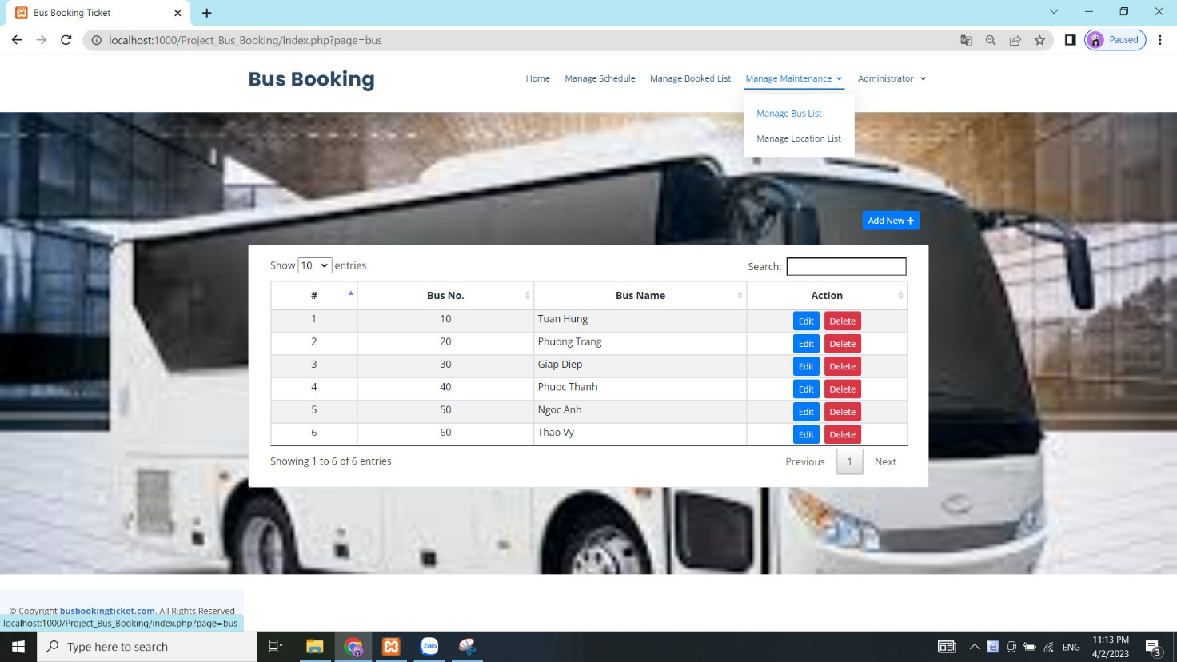

If the administrator wants to add about bus in this page, he needs to click the Add button to proceed with adding a new bus. After clicking on the add button, the system will give a form for the administrator to enter the information of the new bus. If the bus information has been entered, the administrator needs to click the Save button to proceed with adding data to the database.

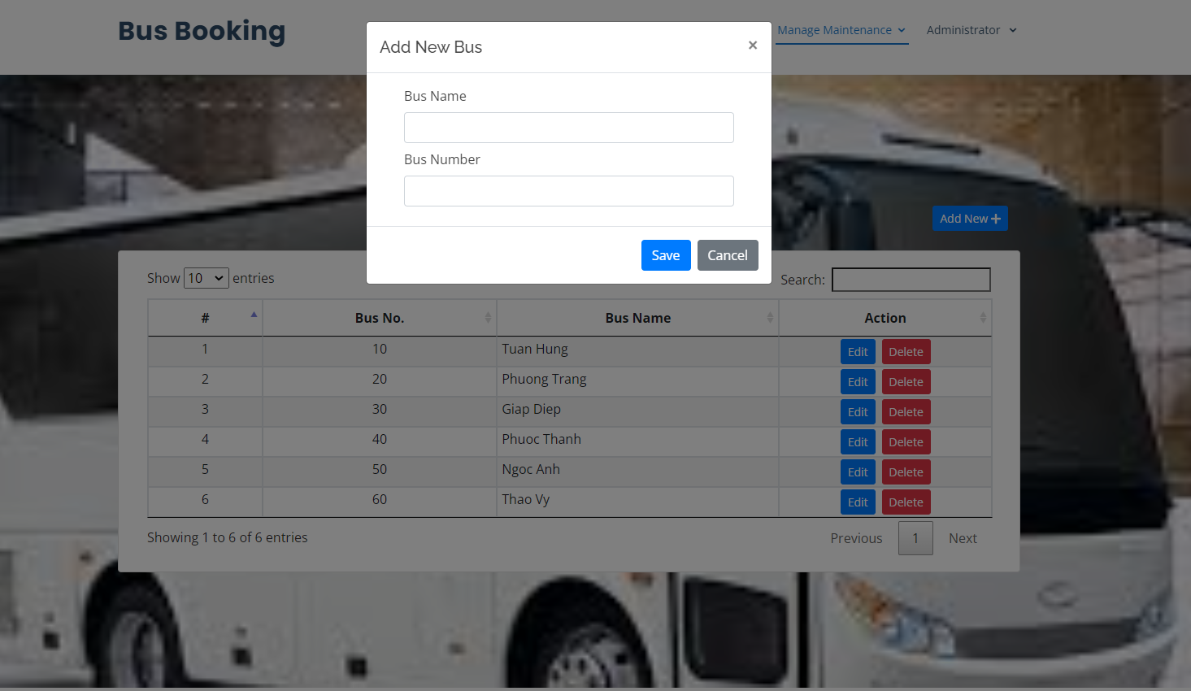

After clicking the Save button, the data is added to the database and the system will display a notification and bus information that has just been added by the administrator.

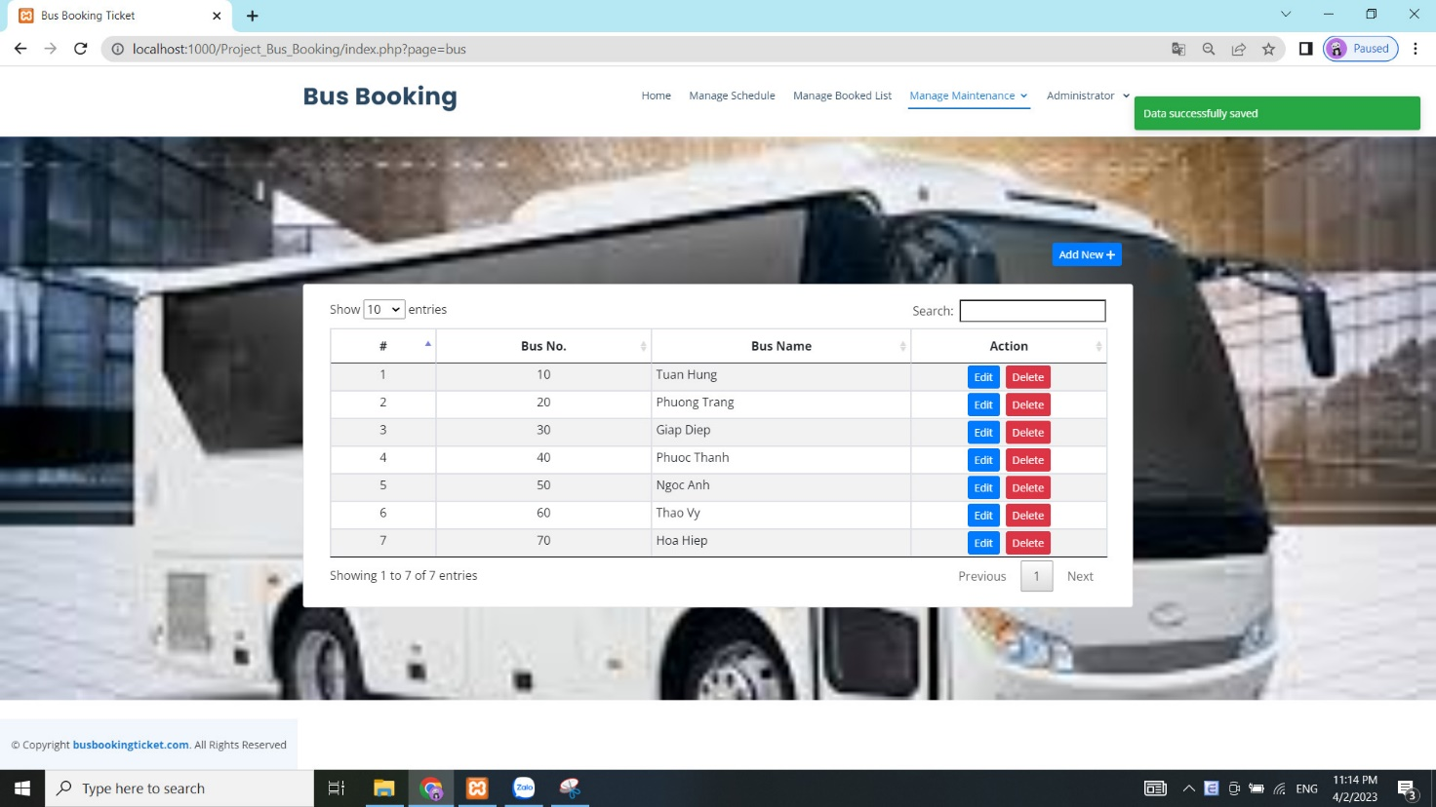

If the administrator wants to edit the bus information, then click the edit button to proceed with the editing. After clicking the Edit button, the system will display the bus information that the administrator wants to edit. After editing the information, the administrator needs to click the Save button to proceed to save the bus information.

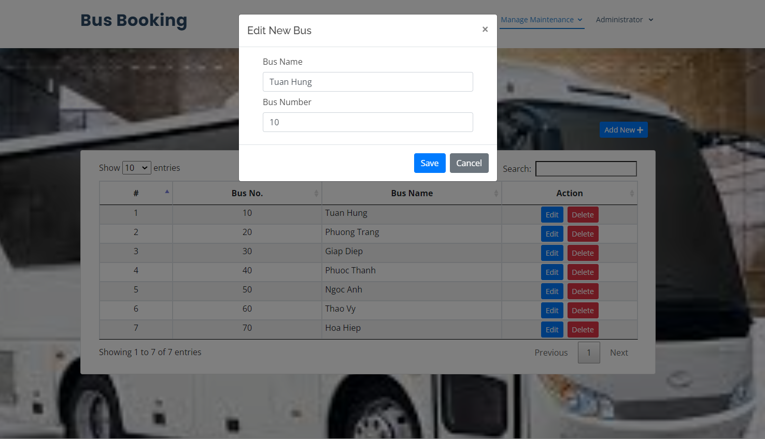

After the administrator has edited the bus information that he wants, then the administrator needs to click the Save button to proceed to save the edited information. This information will be updated into the database by the system, and the system will display the message and the revised bus information.

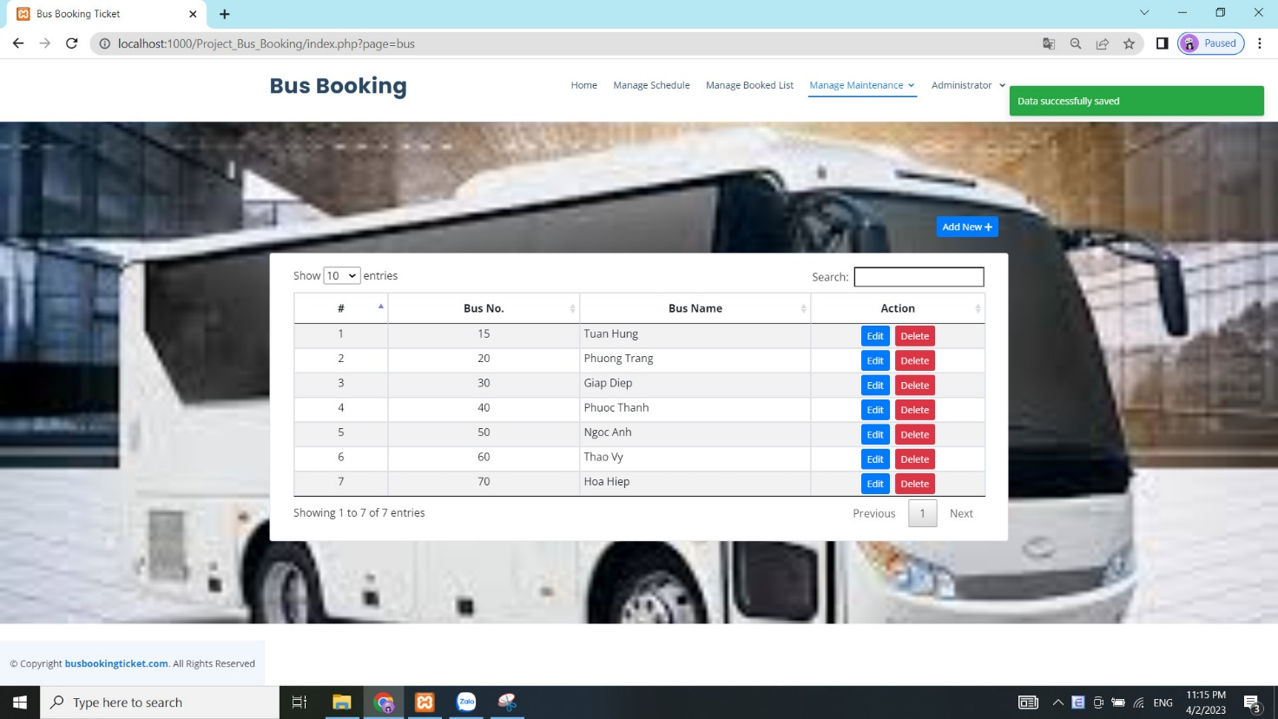

If the administrator wants to delete a certain bus, click the Delete button there to proceed with the deletion. After clicking the Delete button, the system will display a message that the administrator is sure to delete. If you want to delete click the Ok button, otherwise, if you don't want to delete, click the Cancel button.

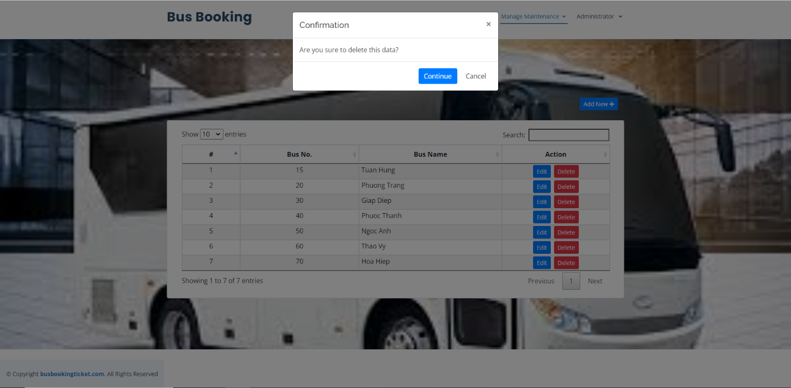

After the administrator wants to delete and clicks the Ok button, the bus data is deleted by the system in the database and displays a successful deletion message to the administrator.

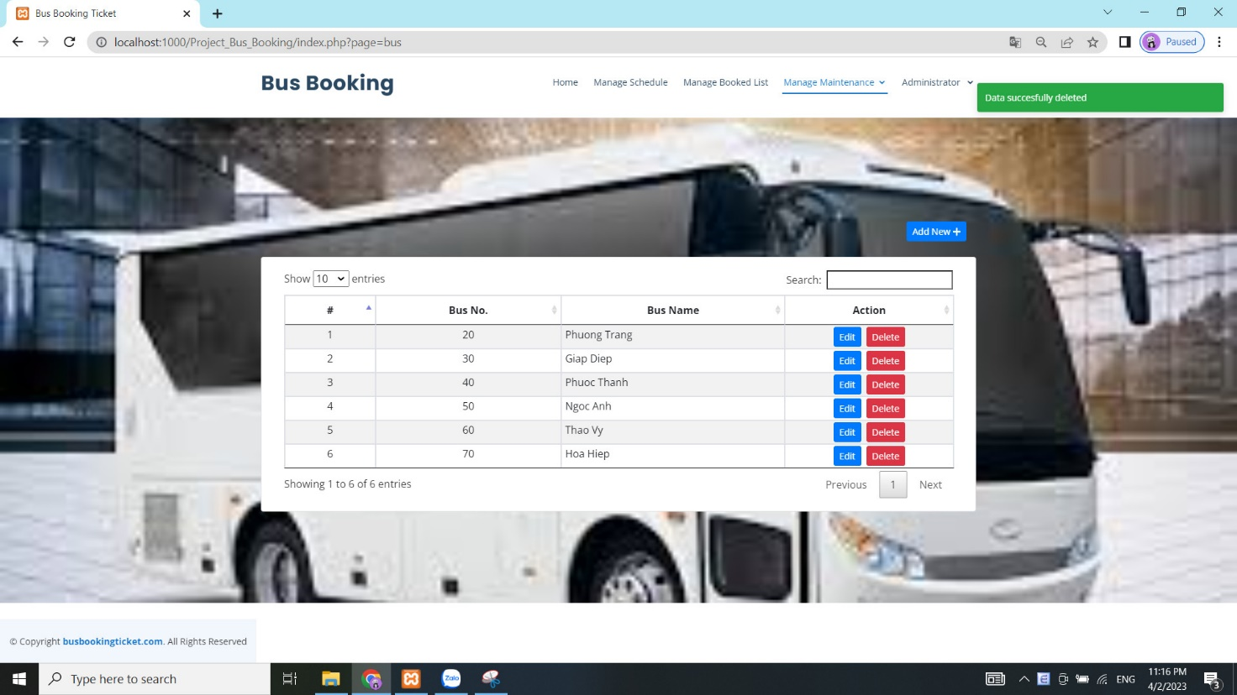

Next in the admin section for administrators will be Manage Location List. In this page, the system will display information about location. In this page, the administrator will have the functions to edit and delete location information.

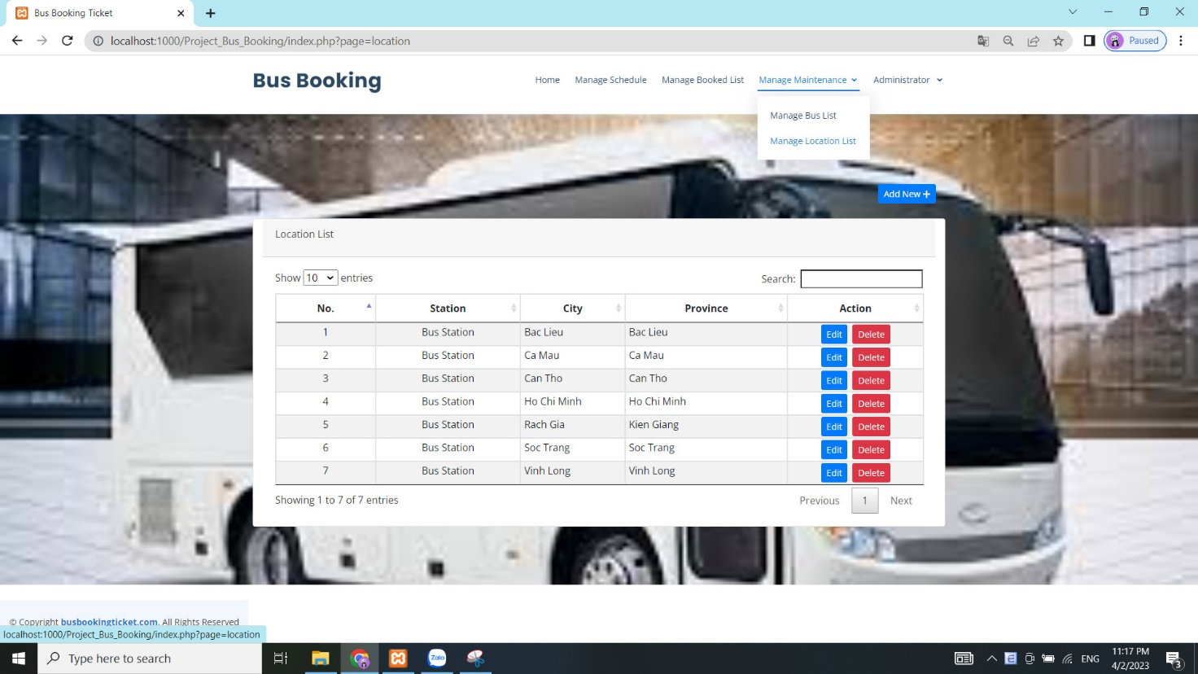

If the administrator wants to add about location in this page, he needs to click the Add button to proceed with adding a new location. After clicking on the add button, the system will give a form for the administrator to enter the information of the new location. If the bus information has been entered, the administrator needs to click the Save button to proceed with adding data to the database.

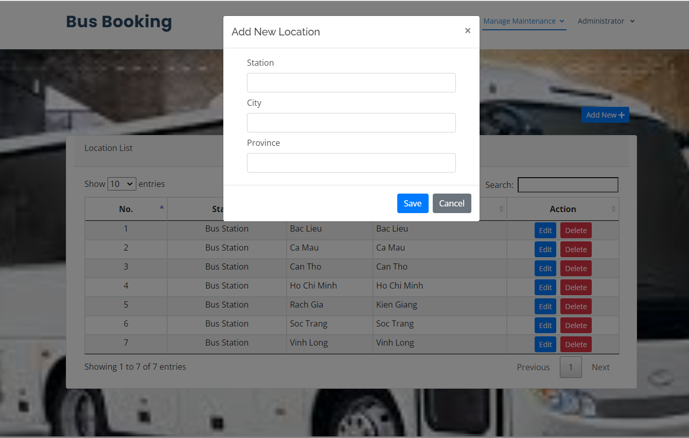

After clicking the Save button, the data is added to the database and the system will display a notification and location information that has just been added by the administrator.

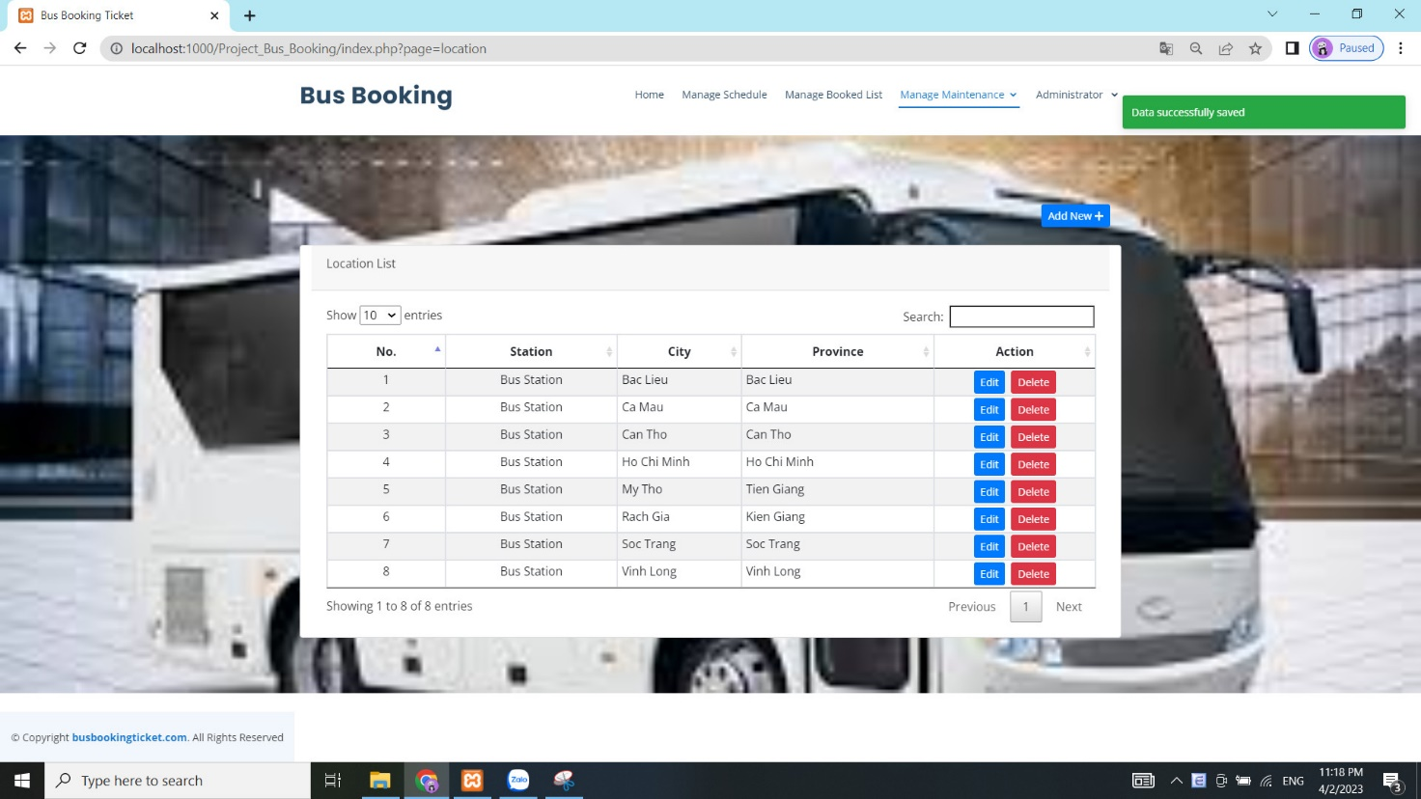

If the administrator wants to edit the location information, then click the edit button to proceed with the editing. After clicking the Edit button, the system will display the bus information that the administrator wants to edit. After editing the information, the administrator needs to click the Save button to proceed to save the location information.

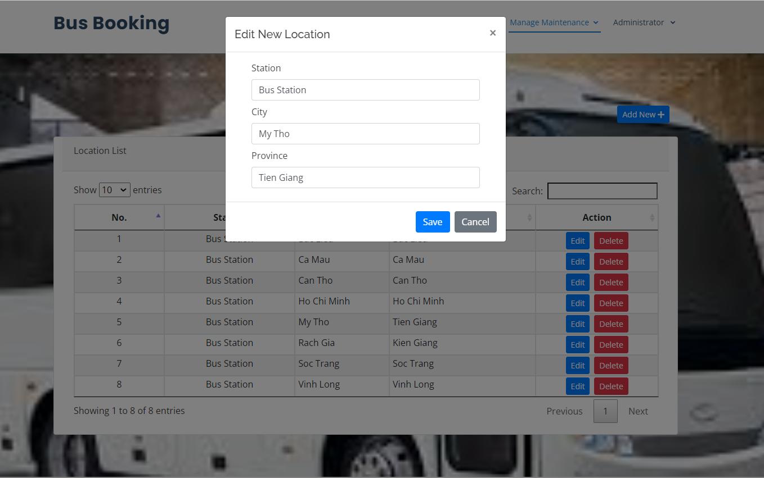

After the administrator has edited the location information that he wants, then the administrator needs to click the Save button to proceed to save the edited information. This information will be updated into the database by the system, and the system will display the message and the revised location information.

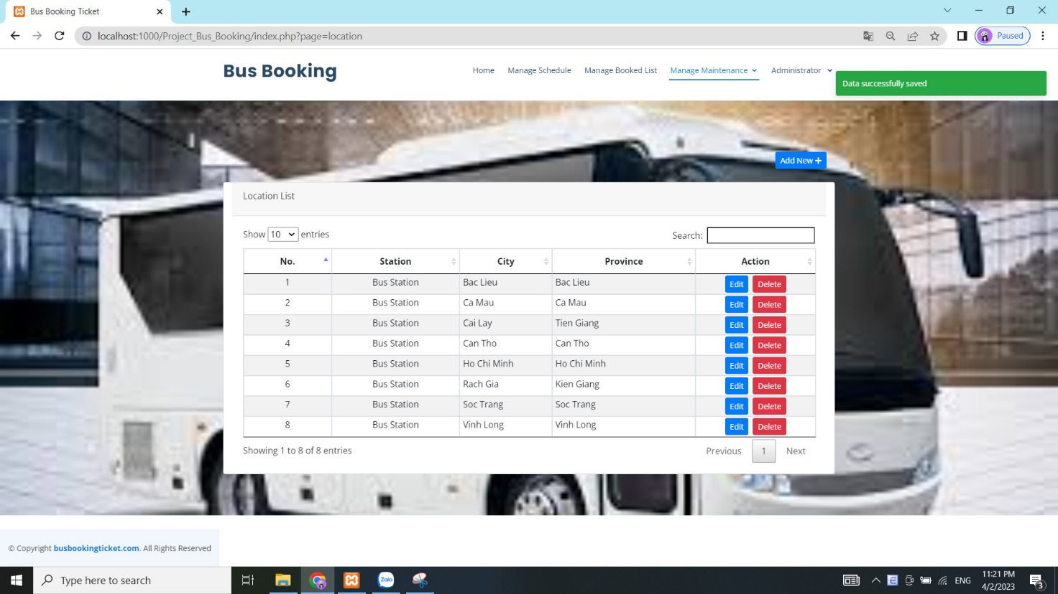

If the administrator wants to delete a certain location, click the Delete button there to proceed with the deletion. After clicking the Delete button, the system will display a message that the administrator is sure to delete. If you want to delete click the Ok button, otherwise, if you don't want to delete, click the Cancel button.

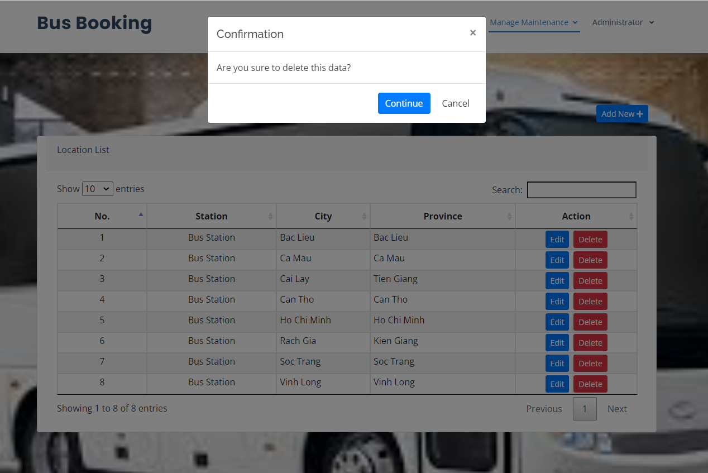

After the administrator wants to delete and clicks the Ok button, the location data is deleted by the system in the database and displays a successful deletion message to the administrator.

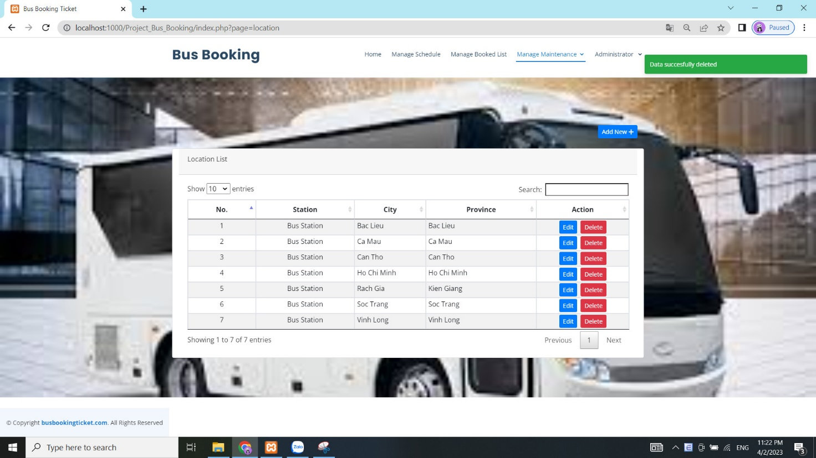

Next in the admin section for administrators will be Manage Staff List. In this page, the system will display information about staff or admin. In this page, the administrator will have the functions to edit and delete staff or admin information.

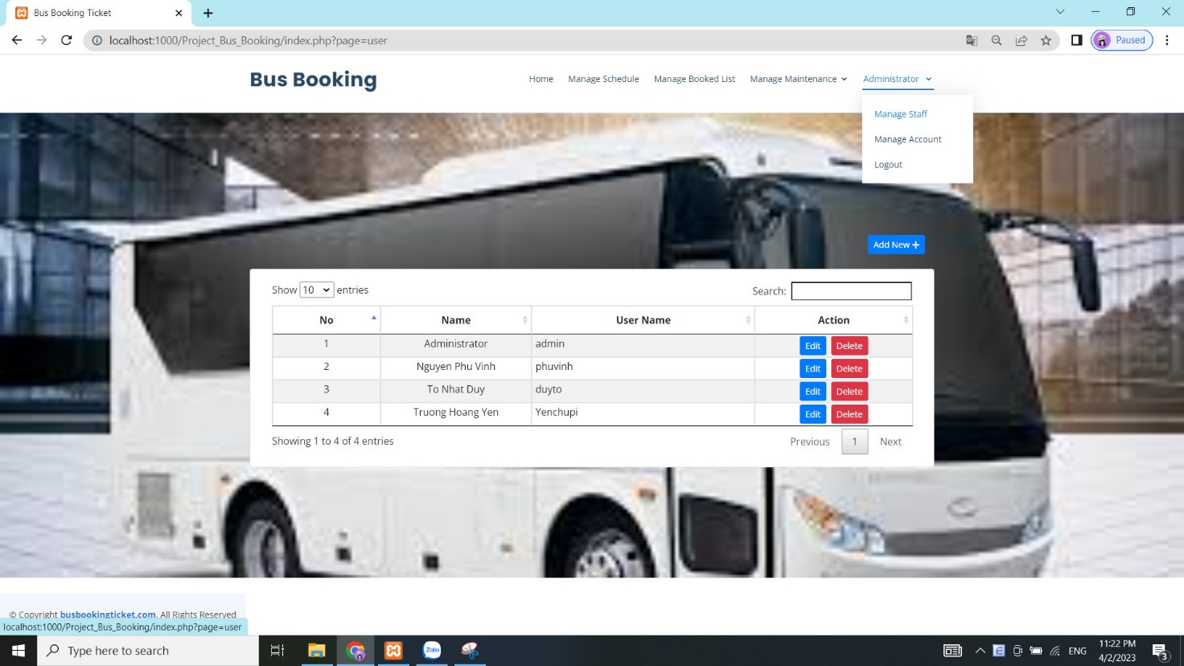

If the administrator wants to add about staff or admin in this page, he needs to click the Add button to proceed with adding a new staff or admin. After clicking on the add button, the system will give a form for the administrator to enter the information of the new staff or admin. If the bus information has been entered, the administrator needs to click the Save button to proceed with adding data to the database.

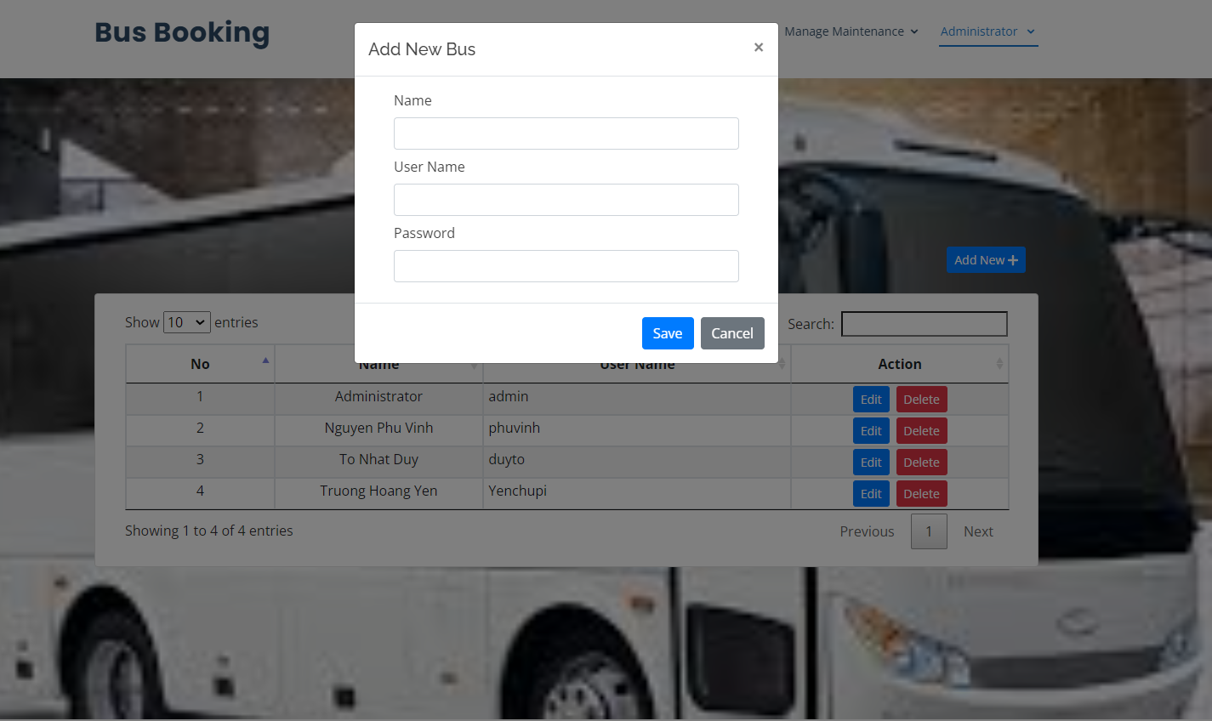

After clicking the Save button, the data is added to the database and the system will display a notification and location information that has just been added by the administrator.

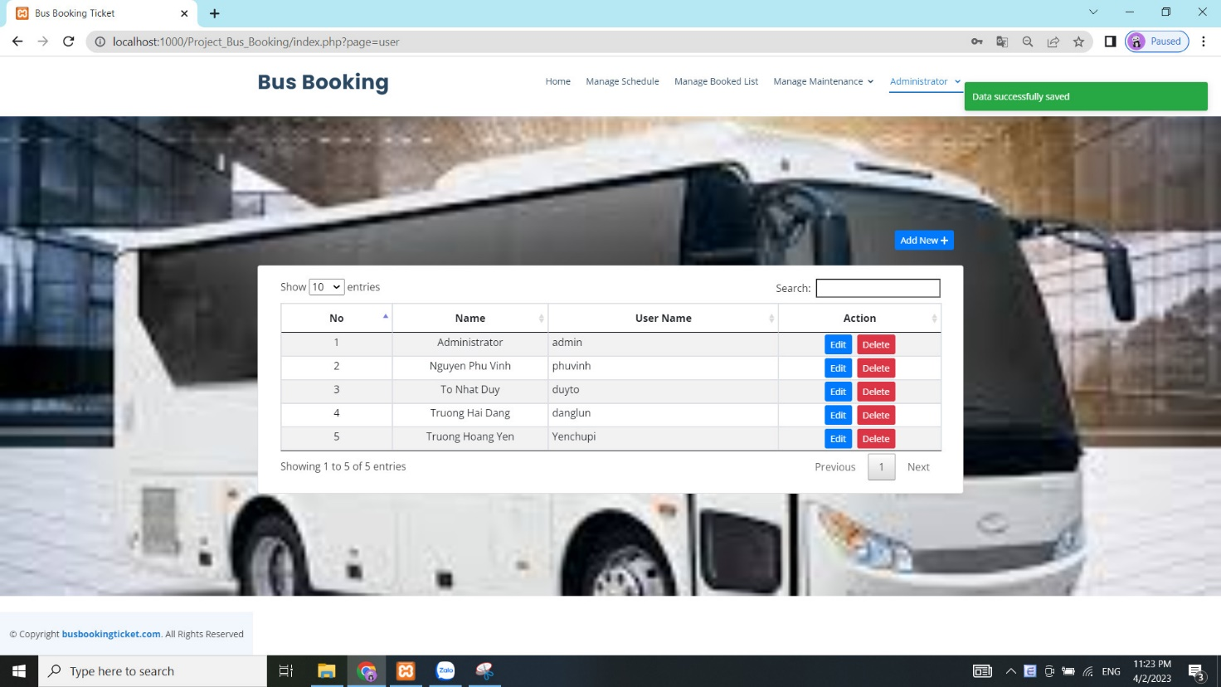

If the administrator wants to edit the staff or admin information, then click the edit button to proceed with the editing. After clicking the Edit button, the system will display the staff or admin information that the administrator wants to edit. After editing the information, the administrator needs to click the Save button to proceed to save the staff or admin information.

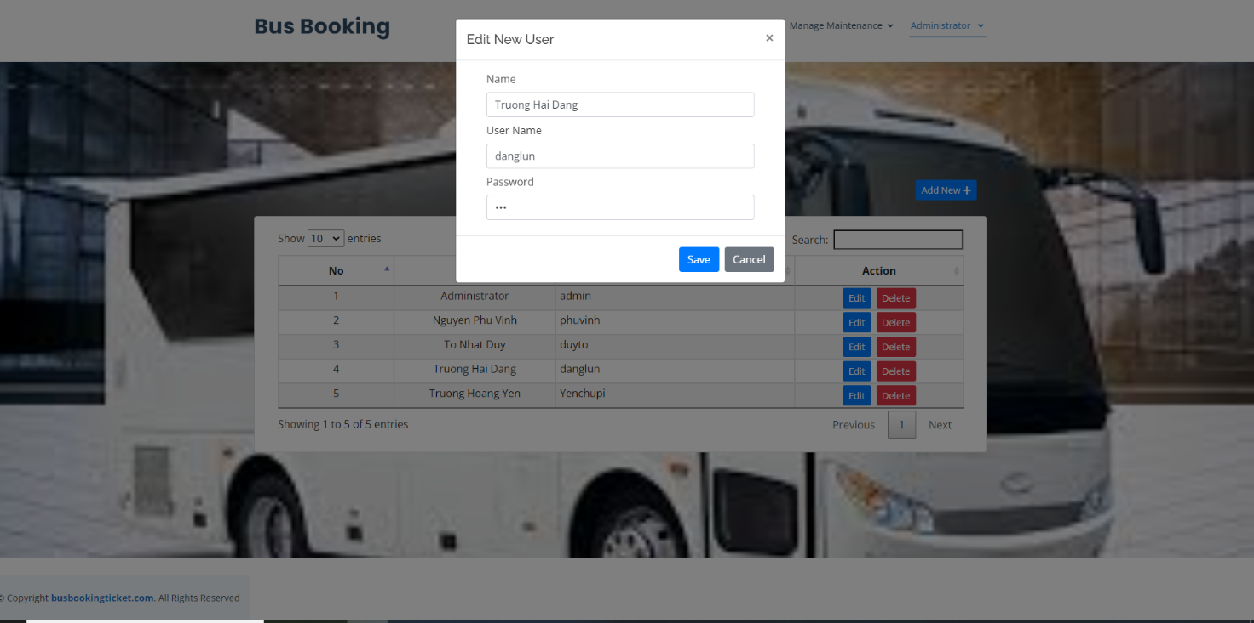

After the administrator has edited the staff or admin information that he wants, then the administrator needs to click the Save button to proceed to save the edited information. This information will be updated into the database by the system, and the system will display the message and the revised staff or admin information.

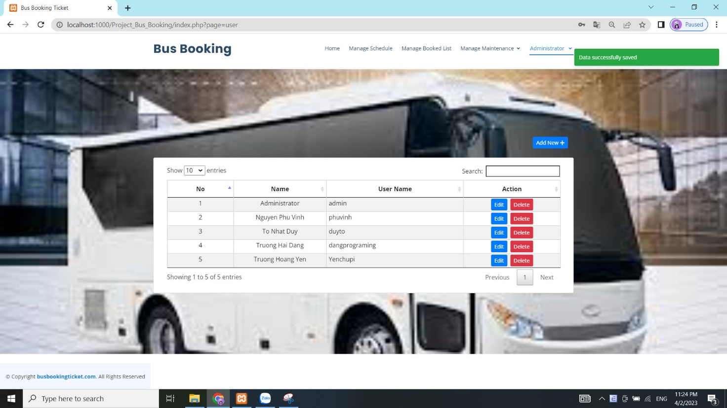

If the administrator wants to delete a certain staff or admin, click the Delete button there to proceed with the deletion. After clicking the Delete button, the system will display a message that the administrator is sure to delete. If you want to delete click the Ok button, otherwise, if you don't want to delete, click the Cancel button.

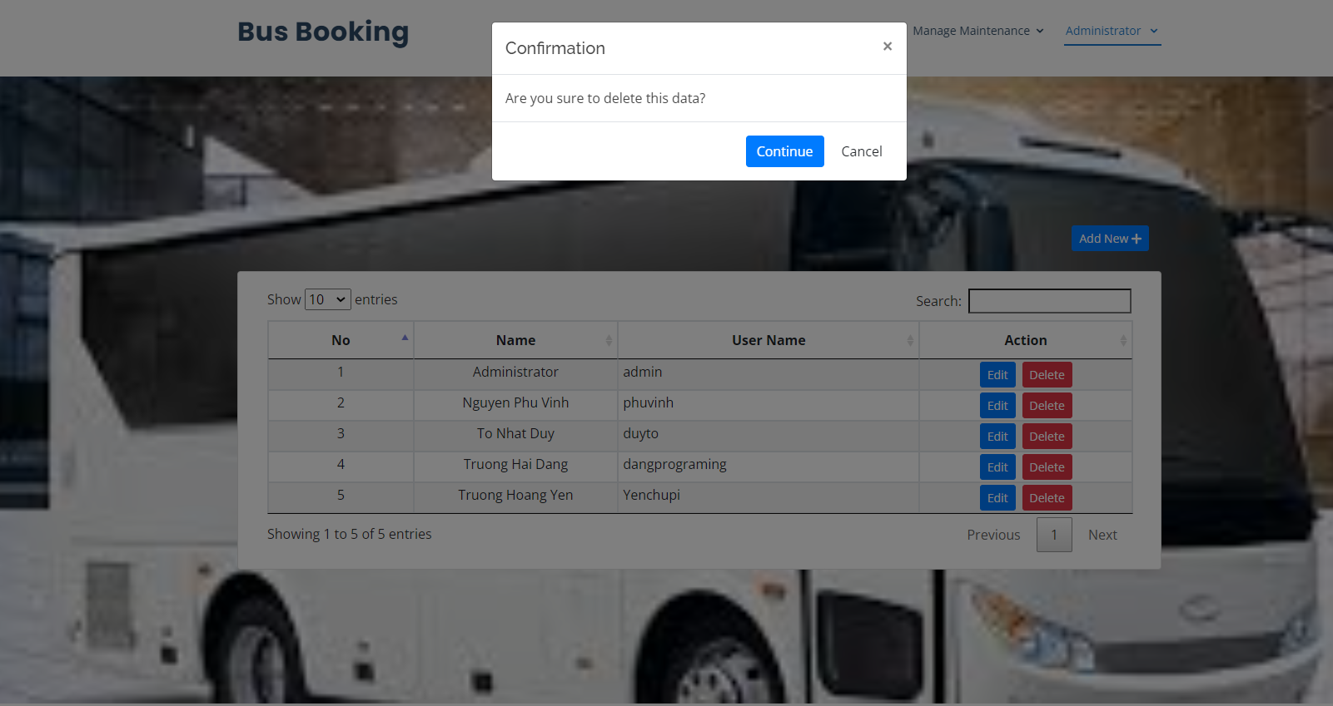

After the administrator wants to delete and clicks the Ok button, the staff or admin data is deleted by the system in the database and displays a successful deletion message to the administrator.

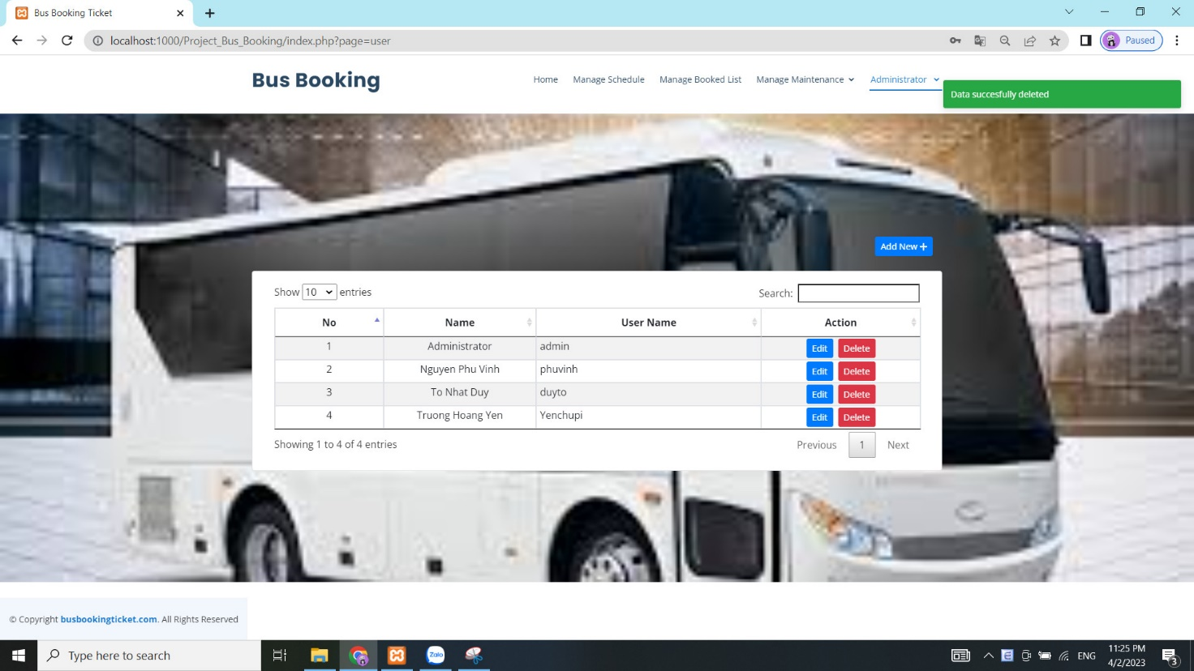

Next, the administrator wants to exit the system, just click on Logout. The system will take the administrator account out of the system and return to the login page for the administrator.

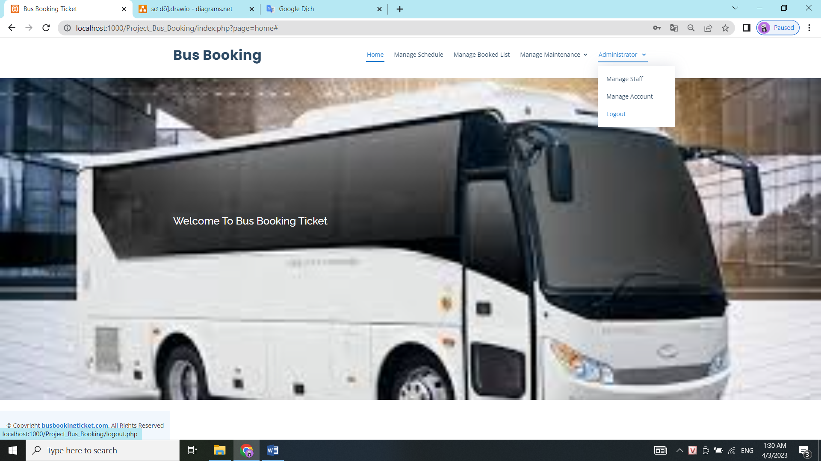

# Testing

**Table :** Test case

|  |  |  |  |  |  |
| --- | --- | --- | --- | --- | --- |
| **No.** | **Test case** | **Function** | **Expected Result** | **Actual Result** | **Result** |
| 1 | Verify that the user when entering information and search for bus ticket information | Searching ticket | Display information of bus ticket | Display information of bus ticket | Pass |
| 2 | Verify that user input information and search for bus ticket information and display a message when no data is available | Display no data message | Display no data message | Pass |
| 3 | Verify that the user when booking the ticket but the bus ticket in that bus is sold out and display a message that the bus ticket is sold out | Booking ticket | Display message | Display message | Pass |
| 4 | Verify that the user when booking with trip information displayed when filling in the booking information | Display information trip | Display information trip | Pass |
| 5 | Verify that the user who booked the bus ticket, the system will show the seat location to the person who chooses the seat | Display information seat | Display information seat | Fail |
| 6 | Verify that user when booking ticket does not fill in all information and error message for user to re-enter full information | Show slow motion and let the user reload to fill in the information again | Show slow motion and let the user reload to fill in the information again | Pass |
| 7 | Verify that the user will provide a sequence of numbers when the ticket is booked | Display numbers | Display numbers | Pass |
| 8 | Verify that the user when clicking on the Contact tab will display the system's contact information, address, and phone number. | Contact Page | Display information contact | Display information contact | Pass |
| 9 | Verify that admin when clicking on the admin Login tab will display the admin login page | Admin login page | Display the admin login page | Display the admin login page | Pass |
| 10 | Verify that the admin, once the login information has been entered, the system will be redirected to the admin website page | Display the admin website page | Display the admin website page | Pass |
| 11 | Verify that the administrator when entering incorrect or missing login information, the system will display a message for admin to login again | Display message | Display message | Pass |
| 12 | Verify that the administrator clicking on Manage Maintenance and selecting Manage Bus List will display the Manage Bus List page | Manage Bus List page | Display Manage Bus List page | Display Manage Bus List page | Pass |
| 13 | Verify that when the administrator clicks on Add New, the system will display the information that needs to be added. | Display the information that needs to be added | Display the information that needs to be added | Pass |
| 14 | Verify that admin when add does not fill in all information and error message for user to re-enter full information | Show slow motion and let the admin reload to fill in the information again | Display the information that needs to be added | Pass |
| 15 | Verify that the admin clicks on Save button and the admin confirms that it will add and displays a message add successfully. | Display message | Display message | Pass |
| 16 | Verify that when the administrator clicks on Edit, the system will display the information that needs to be edited. | Display the information that needs to be edited. | Show slow motion and let the admin reload to fill in the information again | Pass |
| 17 | Verify that the admin clicks on Save button and the admin confirms that it will add and displays a message edit successfully. | Display message | Display message | Pass |
| 18 | Verify that when the administrator clicks on Delete, the system will display the information that needs to be deleted. | Display the information that needs to be deleted. | Display the information that needs to be deleted. | Pass |
| 19 | Verify that the administrator when clicking on Delete, the system will display a confirmation message whether the admin wants to really delete or not | Display message | Display message | Pass |
| 20 | Verify that the admin clicks on Delete and the admin confirms that it will delete and displays a message delete successfully. | Display message | Display message | Pass |
| 21 | Verify that the administrator when entering the search information in the search bar the system will display the information the administrator is looking for | Display data | Display data | Pass |
| 22 | Verify that the administrator when entering search information in the system search bar displays a message when no data is available. | Display message | Display message | Pass |
| 23 | Verify that the administrator clicking on Manage Maintenance and selecting Manage Location List will display the Manage Location List page | Manage Location List page | Display Manage Location List page | Display Manage Location List page | Pass |
| 24 | Verify that when the administrator clicks on Add New, the system will display the information that needs to be added. | Display the information that needs to be added | Display the information that needs to be added | Pass |
| 25 | Verify that admin when add does not fill in all information and error message for user to re-enter full information | Show slow motion and let the admin reload to fill in the information again | Display the information that needs to be added | Pass |
| 26 | Verify that the admin clicks on Save button and the admin confirms that it will add and displays a message add successfully. | Display message | Display message | Pass |
| 27 | Verify that when the administrator clicks on Edit, the system will display the information that needs to be edited. | Display the information that needs to be edited. | Show slow motion and let the admin reload to fill in the information again | Pass |
| 28 | Verify that the admin clicks on Save button and the admin confirms that it will add and displays a message edit successfully. | Display message | Display message | Pass |
| 29 | Verify that when the administrator clicks on Delete, the system will display the information that needs to be deleted. | Display the information that needs to be deleted. | Display the information that needs to be deleted. | Pass |
| 30 | Verify that the administrator when clicking on Delete, the system will display a confirmation message whether the admin wants to really delete or not | Display message | Display message | Pass |
| 31 | Verify that the admin clicks on Delete and the admin confirms that it will delete and displays a message delete successfully. | Display message | Display message | Pass |
| 32 | Verify that the administrator when entering the search information in the search bar the system will display the information the administrator is looking for | Display data | Display data | Pass |
| 33 | Verify that the administrator when entering search information in the system search bar displays a message when no data is available. | Display message | Display message | Pass |
| 34 | Verify that the administrator clicking on Manage Book List will display the Manage Book List page | Manage Book List page | Display Manage Book List page | Display Manage Book List page | Pass |
| 35 | Verify that when the administrator clicks on Add New, the system will display the information that needs to be added. | Display the information that needs to be added | Display the information that needs to be added | Pass |
| 36 | Verify that admin when add does not fill in all information and error message for user to re-enter full information | Show slow motion and let the admin reload to fill in the information again | Display the information that needs to be added | Pass |
| 37 | Verify that the admin clicks on Save button and the admin confirms that it will add and displays a message add successfully. | Display message | Display message | Pass |
| 38 | Verify that when the administrator clicks on Edit, the system will display the information that needs to be edited. | Display the information that needs to be edited. | Show slow motion and let the admin reload to fill in the information again | Pass |
| 39 | Verify that the admin clicks on Save button and the admin confirms that it will add and displays a message edit successfully. | Display message | Display message | Pass |
| 40 | Verify that when the administrator clicks on Delete, the system will display the information that needs to be deleted. | Display the information that needs to be deleted. | Display the information that needs to be deleted. | Pass |
| 41 | Verify that the administrator when clicking on Delete, the system will display a confirmation message whether the admin wants to really delete or not | Display message | Display message | Pass |
| 42 | Verify that the admin clicks on Delete and the admin confirms that it will delete and displays a message delete successfully. | Display message | Display message | Pass |
| 43 | Verify that the administrator when entering the search information in the search bar the system will display the information the administrator is looking for | Display data | Display data | Pass |
| 44 | Verify that the administrator when entering search information in the system search bar displays a message when no data is available. | Display message | Display message | Pass |
| 45 | Verify that the administrator clicking on Manage Schedule will display the Manage Schedule page | Manage Schedule page | Display Manage Schedule page | Display Manage Schedule page | Pass |
| 46 | Verify that when the administrator clicks on Add New, the system will display the information that needs to be added. | Display the information that needs to be added | Display the information that needs to be added | Pass |
| 47 | verify admin when add does not fill in all information and error message for user to re-enter full information | Show slow motion and let the admin reload to fill in the information again | Display the information that needs to be added |  |
| 48 | Verify that the admin clicks on Save button and the admin confirms that it will add and displays a message add successfully. | Display message | Display message | Pass |
| 49 | Verify that when the administrator clicks on Edit, the system will display the information that needs to be edited. | Display the information that needs to be edited. | Show slow motion and let the admin reload to fill in the information again | Pass |
| 50 | Verify that the admin clicks on Save button and the admin confirms that it will add and displays a message edit successfully. | Display message | Display message | Pass |
| 51 | Verify that when the administrator clicks on Delete, the system will display the information that needs to be deleted. | Display the information that needs to be deleted. | Display the information that needs to be deleted. | Pass |
| 52 | Verify that the administrator when clicking on Delete, the system will display a confirmation message whether the admin wants to really delete or not | Display message | Display message | Pass |
| 53 | Verify that the admin clicks on Delete and the admin confirms that it will delete and displays a message delete successfully. | Display message | Display message | Pass |
| 54 | Verify that the administrator when entering the search information in the search bar the system will display the information the administrator is looking for | Display data | Display data | Pass |
| 55 | Verify that the administrator when entering search information in the system search bar displays a message when no data is available. | Display message | Display message | Pass |
| 56 | Verify that the administrator clicking on name admin and selecting Manage Staff will display the Manage Staff page | Manage staff page | Display Manage staff page | Display Manage staff page | Pass |
| 57 | Verify that when the administrator clicks on Add New, the system will display the information that needs to be added. | Display the information that needs to be added | Display the information that needs to be added | Pass |
| 58 | Verify that admin when add does not fill in all information and error message for user to re-enter full information | Show slow motion and let the admin reload to fill in the information again | Display the information that needs to be added | Pass |
| 59 | Verify that the admin clicks on Save button and the admin confirms that it will add and displays a message add successfully. | Display message | Display message | Pass |
| 60 | Verify that when the administrator clicks on Edit, the system will display the information that needs to be edited. | Display the information that needs to be edited. | Show slow motion and let the admin reload to fill in the information again | Pass |
| 61 | Verify that the admin clicks on Save button and the admin confirms that it will add and displays a message edit successfully. | Display message | Display message | Pass |
| 62 | Verify that when the administrator clicks on Delete, the system will display the information that needs to be deleted. | Display the information that needs to be deleted. | Display the information that needs to be deleted. | Pass |
| 63 | Verify that the administrator when clicking on Delete, the system will display a confirmation message whether the admin wants to really delete or not | Display message | Display message | Pass |
| 64 | Verify that the admin clicks on Delete and the admin confirms that it will delete and displays a message delete successfully. | Display message | Display message | Pass |
| 65 | Verify that the administrator when entering the search information in the search bar the system will display the information the administrator is looking for | Display data | Display data | Pass |
| 66 | Verify that the administrator when entering search information in the system search bar displays a message when no data is available. | Display message | Display message | Pass |
| 67 | Verify that the administrator clicking on name admin and selecting Manage Account will display information account admin. | Manage Account page | Display Manage Account page | Display Manage Account page | Pass |
| 68 | Verify that when the administrator wants to edit the information, the admin needs to edit what information needs to be corrected and click the Save button, the system will save the information and display the message. | Update Account | Display message | Display message | Pass |
| 69 | Verify that the administrator clicks on the administrator's name and selects Logout and selects that the system will log out of the system. | Logout | Logout successfully | Logout successfully | Pass |

# Evaluation

## Summarised Key findings from the project

The project has some key detection keywords as follows: booking, schedule, management, customer, bus, search, location, membership, information, price list, rides, online, check-in, booking, departures, accounts, mobile apps, security, and statistics. These keywords are used to describe the basic features of the bus ticketing application, including schedule management, ticket booking, ride search, online payment, customer information management and account, view price list, and data statistics, as well as ensure the security of customer data. These keywords also provide users and administrators with an overview of the bus ticket booking application's features and utilities.

## Recommendations for future development

In the future, when I will develop the bus ticket booking project, I will create a complete and user-friendly application. My application will allow customers to search and book tickets quickly and easily on various routes, and they can also track information about the trip. In addition, my application will also provide administrators with a set of easy management tools, helping them control and process information related to bus schedules, bus tickets, customer information, vehicle location and account. And I will also make sure that booking and information management is done in a more flexible way. I will use new technologies like artificial intelligence, machine learning and data mining to provide users with suggestions and predictions regarding the lowest schedules, deals, fares and more. This will help users save a lot of time and money while booking bus tickets.

In addition, I will also focus on enhancing the user experience, allowing them maximum access from mobile and desktop devices. My application will be designed to meet the diverse needs of customers, from searching for rides to paying for tickets online. In addition, I will also invest in high security features to ensure the safety of customer information. By focusing on these factors, I will build an out-of-the-box application that will make booking bus tickets easier than ever. Also, I should create rich features to enhance user experience, including reservation mechanism, membership registration and account management. I can also provide customers with games or entertainment on the app so that they can stay entertained during the trip. It all helps customers feel happy and excited when using your app.

These improvements will help me increase the value of my services and provide customers with a complete and comfortable experience when booking bus tickets. With the application's diverse and high-quality features, you can attract more customers and increase revenue for your bus ticketing project.

## Project Evaluation

Building a website project to book bus tickets in PHP is a great impression in the field of information technology. This is because using PHP has made the website development process easier, which in turn saves time.

Developing a PHP-based bus ticketing system requires a good understanding of the respective languages and technologies. However, the development has approached this project professionally and delicately. By choosing the most suitable technologies for implementation and designing beautiful and friendly user interfaces. However, in the process of using, there are still some points that need to be improved such as developing more features, improving system performance and enhancing service quality.

Overall, the project of building a bus ticketing system in PHP language has brought new conveniences and values to developers and customers. The use of PHP language has helped to develop and deploy projects quickly, with high efficiency, to meet the increasing demands of customers for transportation.

## Personal Evaluation

During the project, I learned a lot of important skills such as how to build a beautiful website, increase security, and better support users. It is thanks to the use of PHP language to develop the system. I designed the interface, developed and tested new features.

However, it is also a challenge for a student like me. So I tried my best to get the job done and on time. I am extremely satisfied with the end result of the project. The bus ticketing system works well and meets the needs of customers. This project helped me develop my skills.

## Conclusion

Completed the construction of a bus ticket booking website system in PHP language, this system allows users to search and select their trip schedule. However, the feature of choosing a seat and paying directly by banking and scanning the code has not yet been integrated into the system. I consider the idea of direct payment unnecessary, because it can cause trouble if the user has an unexpected business and cancels a previously booked trip. It is better to continue with the payment at the counter after the user completes the trip.

The admin side has management features such as schedule, booking information, vehicle information, location information, accounts and employees with functions of adding, editing, deleting and searching, helping admin Users can easily manage and maintain the system conveniently.

In the process of building the project, I have learned many skills, from requirements analysis and planning to programming and thinking skills. In particular, I have gained perseverance and direction for big projects in the future.

In the future, I will integrate more seat selection and direct payment through banking and code scanning to improve the user experience. I believe that the development of this project will bring value and create many development opportunities for me and the users of the system.

# References

# Appendix A – Project Proposal

# Appendix B

# Appendix C

1. <https://cdn.computercareers.org/wp-content/uploads/Hypertext-Markup-Language.jpg.webp>
2. <https://longvan.net/hinhanh/tintuc/css-la-gi1.jpg>
3. <https://flatironschool.com/legacy-assets/images.ctfassets.net/hkpf2qd2vxgx/1nwTVX3XLCMxvLDxuZqBVI/b890e412820dfaa6657bb407f704bd41/JavaScript_What_can_you_build_with_JavaScript.png>
4. <https://upload.wikimedia.org/wikipedia/commons/thumb/2/27/PHP-logo.svg/1200px-PHP-logo.svg.png>
5. <https://store-images.s-microsoft.com/image/apps.1409.13851527096222888.2b60149a-04a5-4578-a6b2-d7b7377332d5.c22d8e97-4d44-4304-9bd2-55f9d29c0f82>
6. <https://www.w3schools.com/whatis/img_ajax.jpg>